**CHAPTER-1**

**INTRODUCTION**

* 1. **INTRODUCTION:**

In today's interconnected digital landscape, cybersecurity threats are becoming increasingly sophisticated and pervasive. Organizations across various sectors face a constant barrage of cyberattacks, ranging from malware infections and phishing scams to advanced persistent threats (APTs) and ransomware assaults. As a result, the need for robust security measures, proactive monitoring, and efficient incident response has never been greater.

To address these challenges, organizations rely on Security Operations Centers (SOCs) and forensic analysis to detect, investigate, and mitigate cyber threats effectively. These SOC teams serve as the frontline defenders, continuously monitoring networks, systems, and applications for any signs of suspicious activity or security breaches. Additionally, forensic analysis plays a crucial role in understanding the nature and scope of security incidents, enabling organizations to identify the root causes, assess the impact, and develop strategies to prevent future occurrences.

In this series, we will explore the development of a Python-based SOC and forensic analysis framework tailored to meet the evolving needs of modern cybersecurity operations. Leveraging the power and flexibility of Python programming language, we aim to design a comprehensive solution that enhances threat detection, incident response, and forensic investigation capabilities.

**CHAPTER-2**

**LITERATURE SURVEYS**

**2.1 SECURITY OPERATIONS CENTER: A SYSTEMATIC STUDY AND OPEN CHALLENGES**

**Manfred Vielberth , Fabian Bohm , Ines Fichtinger and Gunther Pernul.**

**2.1.1 INTRODUCTION:**

According to a recent report, the average number of security breaches reported by organizations has risen by 11% from 130 in 2017 to 145 incidents in 2018.Over the last five years, this number has risen by a total of 65%. However, this report only covers detected and reported incidents, and the number of unreported incidents is probably much higher. The total annual cost of any type of cyber-attack is also growing at a steady pace. Unfortunately, many attacks go undetected for a surprisingly long time. The mean time to detect an incident was 196 days in 2018, and it took another 69 days on average to contain the breach. This detection time demonstrates how ineffective companies are at detecting and mitigating cyber-attacks. The reasons for this inefficiency include but are not limited to companies not having an overview of their devices, systems, applications, and networks, not knowing which assets to protect, not knowing which tools to use and how to integrate them with the existing infrastructure, or being overwhelmed by the speed technology and the ever-evolving threat landscape.

Security Operations Centers (SOCs) can provide an over-arching solution for detecting and mitigating an attack if implemented correctly. They incorporate a mixture of peo-

ple, processes, technologies, and governance and compliance, to effectively identify, detect, and mitigate threats, ideally before any damage occurrs. However, there are a few research

gaps and challenges associated with SOCs. The biggest issue is the lack of a precise definition of a SOC and its components. For some researchers, a SOC is solely an entity responsible for monitoring the network. For others, it is an organizational unit encompassing all security operations, like incident management and threat intelligence. This lack of consensus hinders companies from deploying efficient SOCs and researchers from further adding to the innovation of SOCs. Therefore, this work’s main contribution is to close this research gap by establishing a ground truth for a state-of-the-art SOC. We conduct a structured literature review to identify and subsume the current state-of-the-art.

**2.1.2 DELIMINATION & DEFINITION:**

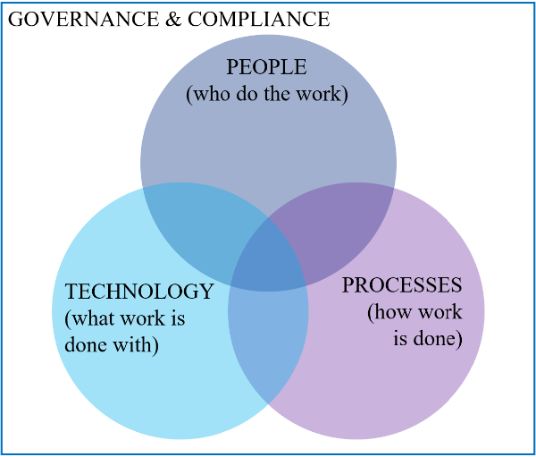

Fig 2.1.1 Governance and Compliance

**Computer Security Incident Response Team:** This term is often used interchangeably for a SOC although it mainly focuses on the response part once an attack has happened. A CSIRT is an organizational unit responsible for coordinating and supporting the response to a computer security incident. A CSIRT is classified either as an independent team or part of a SOC.

**Network Operations Center:** A Network Operations Center (NOC) oversees identifying, investigating, prioritizing, escalating, and resolving problems. However, in NOCs, the addressed problems are different as the NOC focuses on incidents impacting the performance and availability of an organization’s network. As incidents can occur on all systems not just networks, it is beneficial for organizations when the NOC and SOC teams work together.

**Security** **Intelligence Center:** The term Security Intelligence Center (SIC) was first used in 2017 to describe the successor of SOCs. It aims to provide a more holistic, integrated view than a SOC and can fully visualize and manage security intelligence in one place. Therefore, several technologies (e.g. Information Security (IS) knowledge management, big data processing) are combined.

**Security Information and Event Management:** SIEM is an integral part of many SOCs to cover a large part of the technological requirements. It is responsible for collecting security-relevant data in a centralized manner. Thereby, it provides security analytics capabilities by correlating log events. Further functionalities enable enrichment with context data, normalizing heterogeneous data, reporting, and alerting. To allow the exchange of threat information, SIEM provides a connection to cyber threat intelligence exchange platforms, and it involves human security analysts by offering visual security analytics capabilities. It includes log management capabilities by long time storage of event data.

**2.1.3 OPERATING MODELS & INFLUENTIAL FACTORS:**

There are numerous ways of operating a SOC. Broadly speaking, a SOC can be operated internally or externally, However, various other and more specific classifications exist. Schinagl propose clustering the different operating models based on the SOC’s organizational placement and its functionality, such as an integral, a technology-driven, a partly outsourced, and a specialized SOC. A different approach to classify SOC operating models is taken by Zimmerman et al.and adapted by Raduet al. They use a combination of size, authority, and the organizational model and propose to divide SOCs into five different operating models: virtual SOC, small SOC, large SOC, tiered SOC, and national SOC. Another clustering of SOC operating models applies four main categories: dedicated, virtual, outsourced, and hybrid SOC. Independently of the operating model of a SOC, it has to be secured itself. A failing SOC leaves the whole rest of a company vulnerable as attacks might spread undetected.Therefore, special attention must be paid to the security of a SOC.Each operating model has certain advantages and disadvantages, and it is essential to come to a decision upfront. Changing the SOC structure after setting it up will require a considerable amount of time and resource.

However, the choice between SOC operating models is not a trivial task, and the implications of this choice should be thoroughly considered. The literature identifies various factors which influence this choice:

**Company strategy:** The overall business and IT strategy should be consulted to determine which operating model fits best. A SOC strategy should be defined before selecting the respective operating model.

**Industry sector:** The industry sector in which a company mainly operates largely influences the scope of the SOC required.

**Size:** The size of a company also has an impact on the decision, since a small company might not be able to set up and run a SOC on their own or might not even require a rigorously defined SOC .

**Cost:** The costs of internally implementing and maintaining a SOC must be compared with the costs of outsourcing security operations. Initially, deploying an in-house SOC might be more expensive, but such an option might turn out to be more cost-effective in the long term. Costs of finding, hiring, and training SOC staff constitute a significant factor, especially since they might increase due to growing skill-shortage and increasing market demand.

**Time:** It takes a considerable amount of time to set up a SOC. Therefore, alignment with organizational plans and timelines is necessary. Additionally, the time to set up a SOC should be compared to the time needed for outsourcing it.

**Regulations:** Depending on the industry sector, different regulations must be considered. Some might enforce the implementation of an operational SOC, others might forbid the outsourcing of SOC operations altogether, or at least to specific providers who do not comply with the respective regulations.

**Privacy:** Privacy also falls under regulation and must be respected whenever dealing with personal data.

**Availability:** Availability requirements should be considered. Most of the time, the goal is to have a SOC operational 24/7, 365 days a year.

**Management support:** Management support is of crucial importance when setting up a dedicated SOC.If management is not committed and benefits of a SOC are not communicated to upper management, the team might not get the resources needed.

**Integration:** The capabilities of an internal SOC need to be integrated with other IT departments ,whereas, in an external SOC, the provider needs to be integrated to get all the data needed.

**Data loss concerns:** The SOC is most often a central place where a substantial amount of sensitive data is processed. Internal SOCs need to be highly secured,

while for external SOC a trusted provider must be selected, who can ensure that the data is secured against intellectual property theft as well as accidental

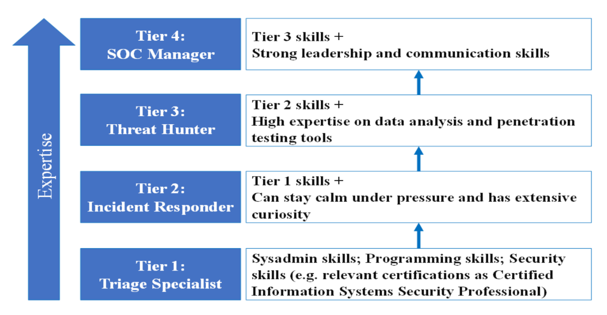loss.

Fig 2.1.2 Necessary skills among SOC roles

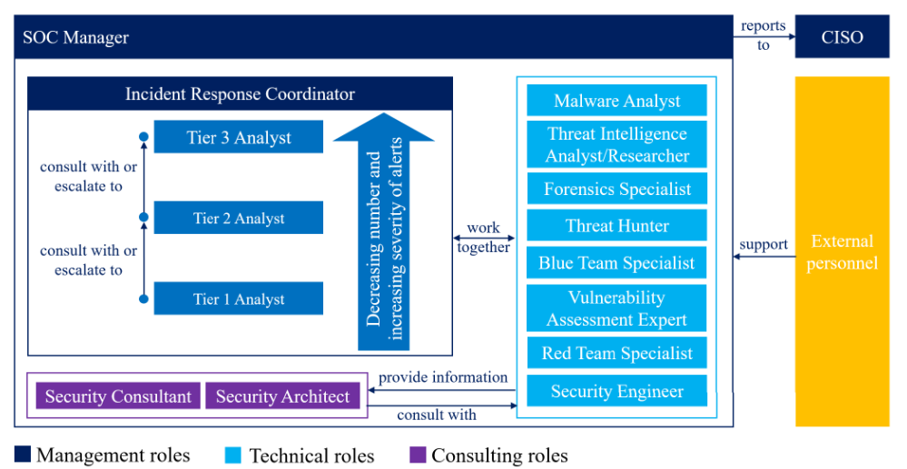

Fig 2.1.3 Interaction of different roles within a SOC

**2.1.4** **PROCESSES**

**2.1.4.1** **COMPREHENSIVE PROCESS DEFINITIONS**:

The review showed that there is only very little literature on the processes within a SOC. As these processes are the core of understanding SOCs and deploying them effectively, the lack of precisely defined processes hinders academia from entirely comprehending what organizations are doing within a SOC. Thus, room for small improvements, let alone innovations, are very hard to identify on an abstract level. This might be the reason for the imbalanced results regarding processes and technology. As there is no abstract, high-level understanding of a SOC’s processes, many researchers focus on trying to improve technologies that might be useful with no clear understanding of which specific process or task of a SOC needs improvement. Also, having a clear understanding of a SOC’s processes, tasks, and interfaces requires the integration with other business processes. This blind spot needs to be closed by academia to understand the processes running in SOCs. Only then will it be possible to advance the current proliferation that is imminent in SOCs in a sustainable manner. Especially ‘‘post-incident activity’’ is barely mentioned in SOC literature, although it is of great importance as it mainly deals with learning and iterative improvement.

**2.1.4.2 ADAPT GENERAL PROCESSES TO SOC:**

Several security standards, regulations, and frameworks define general security-related processes that give rise to the assumption that these can be related at least partially to SOC. These can therefore serve as a basis for a SOC specific process landscape. However, our analysis has not identified any academic literature dealing with how these processes can be related to SOCs. Further research should aim to identify the aspects that apply to SOCs, adapt those to SOC, and extend them by SOC specifics. This could lead simply to a more comprehensive definition and understanding of the processes.

**2.1.4.3 INCREASING COMPLEXITY:**

We see three major challenges for SOCs resulting from the increased complexity of the IT and OT environment in a company: First, the infrastructure is becoming more complicated and intertwined, making it difficult to maintain situational awareness and a cohesive overview. Managers and analysts have poor visibility into the network because they cannot keep track of all the devices in the network. Second, the data captured from the infrastructure is as heterogeneous as its sources making it hard to process, analyze, understand, and link. It also impedes the discovery of whether an event is part of a bigger attack. Third, having more data sources increases the overall number of events and, in many cases, the number of false-positive alerts. It is often mentioned that there is too much (useless) data in general and too many (false positive) alerts. Analysts are overloaded with a high volume of such alerts and face a typical ‘‘needle in a haystack’’ problem when trying to filter the noise. There is not much discussion about the negative impact of false positives on SOCs, although there are controversial opinions like Kokulu et al.

**2.1.4 CONCLUSION:**

The main objective of this work is to identify and compile the current state-of-the-art of SOCs. To thoroughly achieve this goal, we needed to explore the frontiers of academic literature on the topic. This work’s central part consists of a comprehensive literature review on SOCs from a pure research viewpoint. Its objective is to take a close look at SOCs in general but also include their components. The survey is conducted systematically to avoid the exclusion of any relevant information. We planned the review, meaning that the used search terms included various keywords and terms relevant to SOCs. This work includes as many aspects of SOCs as possible. Using the PPTGC framework, various components of a SOC are generally classified into either people, processes, technology, or governance and compliance.We describe these SOC components as currently defined in the literature. We use the relevant literature and the defined state-of-the- art to identify major challenges that hinder further development and innovation for SOCs. The challenges can also serve as a guideline for future research aiming to improve SOCs. Regarding the people working in a SOC, we see a major challenge in recruiting and retaining staff. Training and Awareness play an essential role in addressing this challenge while also helping to increase the company’s overall security posture. When looking at the various processes in a SOC, it is imperative to integrate them with other processes across the whole organization. Analyzing processes regarding SOCs, we can also see that academia and practice lack a thorough and comprehensive definition of the specific processes included in a SOC and their interactions. Without a proper definition of processes, it might not be possible to advance the current state-of-the-art. Technologies promise relief from many repetitive tasks in a SOC; however, most of them are not advanced enough to deliver on the expectations and hype they have created. To maximize the potential of deployed technological solutions, they need to be aligned with and integrated with the rest of an organization’s technological infrastructure. Lastly, an immaturity of SOC governance and compliance aspects has been identified. Compared to people or technological components of a SOC, comprehensive standards and industry-specific guidelines are lacking. This kind of immaturity generally impedes security audits and overall SOC assessments. The lack of standards also prevents various SOC components from advancing since a common baseline of the status-quo has not yet been agreed upon. As we have mainly analyzed academic literature, to provide a more comprehensive picture we aim to include a more practical view by considering information such as case studies in future research. Concluding, SOCs surely help companies to be prepared for cyber-attacks. However, they need to be planned thoroughly, implemented, and integrated very carefully, assessed regularly, and improved continually to unveil their full potential. If done correctly, they improve companies’ ability to prevent hacks, financial losses, and personal data breaches.

**2.2 THE NEXT GENERATION COGNITIVE SECURITY OPERATIONS CENTER: ADAPTIVE ANALYTIC LAMBDA ARCHITECTURE FOR EFFICIENT DEFENSE AGAINST ADVERSARIAL ATTACKS.**

**Konstantinos Demertzis, Nikos Tziritas, Panayiotis Kikiras, Salvador Llopis Sanchez and Lazaros Iliadis**

**2.2.1 INTRODUCTION:**

With an ever-increasing cybersecurity threat landscape to interconnected or networked devices and since the volume of data is growing exponentially, it is more important than ever for critical infrastructures and organizations to be strengthened with intelligent driven security managing and monitoring tools. Using the right combination of these intelligent centralized tools and big data technologies allows classifying risks with high accuracy across network infrastructures to identify sophisticated attacks. Nevertheless, current SOCs focus mostly on human experience and the opinion of experts to evaluate and minimize potential cyber threats. On the other hand, traditional signature-based security systems are unable in most cases to identify evolving threats such as zero-day malware or they produce a vast number of false alarms, thus are proven ineffective as security management tools. The implementation and usage of alternative, more innovative and more effective intelligent methods with fully automated aptitudes appear is necessary to produce an-up-to date SOC that can handle security incidents. Accordingly, SOCs are being forced to consider new ways to boost their cyber defenses such as cloud strategies, big data analytics and artificial intelligence technologies that are emerging as the frontrunner in the fight against cyber-crime. With fully self-governed systems that mimic the functioning of the human brain and help to improve decision-making with minimum human interference, a Next Generation Cognitive Computing SOC (NGC2SOC) is in a far better place to strengthen and reinforce cybersecurity strategies. The ultimate purpose of NGC2SOC comprises sophisticated intelligence driven tactics for real-time investigation of both known and unknown vulnerabilities, immediate access, evidence visualization and additional advanced tools or practices that reduce the potential risk in critical assets combined with a completely automated reinstatement of cybersecurity problems. Machine learning is a practice used to develop sophisticated representations and systems that produce dependable, repeatable decisions and discover unseen or hidden patterns through learning from historical data. In these models, the training and test data are expected to be produced from identical although probably unidentified distributions, thus they have been very sensitive to slight changes in the input or a series of specific transformations. Most of those sensitivities under certain circumstances may lead to altering the behavior of the machine learning algorithms. Specifically, security of machine learning systems is vulnerable to crafted adversarial examples, which may be imperceptible to the human eye, but can lead the model to misclassify the output. In recent times, different types of adversaries based on their threat model leverage these vulnerabilities to compromise a machine learning system where adversaries have high incentives. An adversarial attack is an attempt to maliciously operate the input data or manipulate specific weaknesses of machine learning procedures to compromise the entire security system. For example, a classification process by a trained neural network classifier decides which class a new remark fits based on a training set of data covering remarks whose class association is known. The classification threshold is imperfect and an appropriately designed and implemented adversarial attack, which corresponds to a modified input that may come from a modified dataset, can lead the algorithm to a wrong solution (wrong class). This is because the neural networks operate on high-dimensional data, they are sensitive to overfitting, they can be too linear and they are characterized by the inherent uncertainty of their predictions.

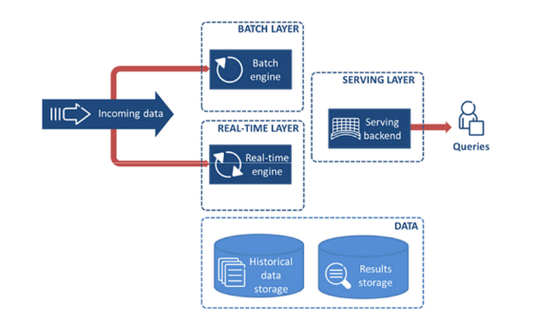**2.2.2 FRAMEWORK ARCHITECTURE:**

Fig 2.2.1 Lambda Architecture

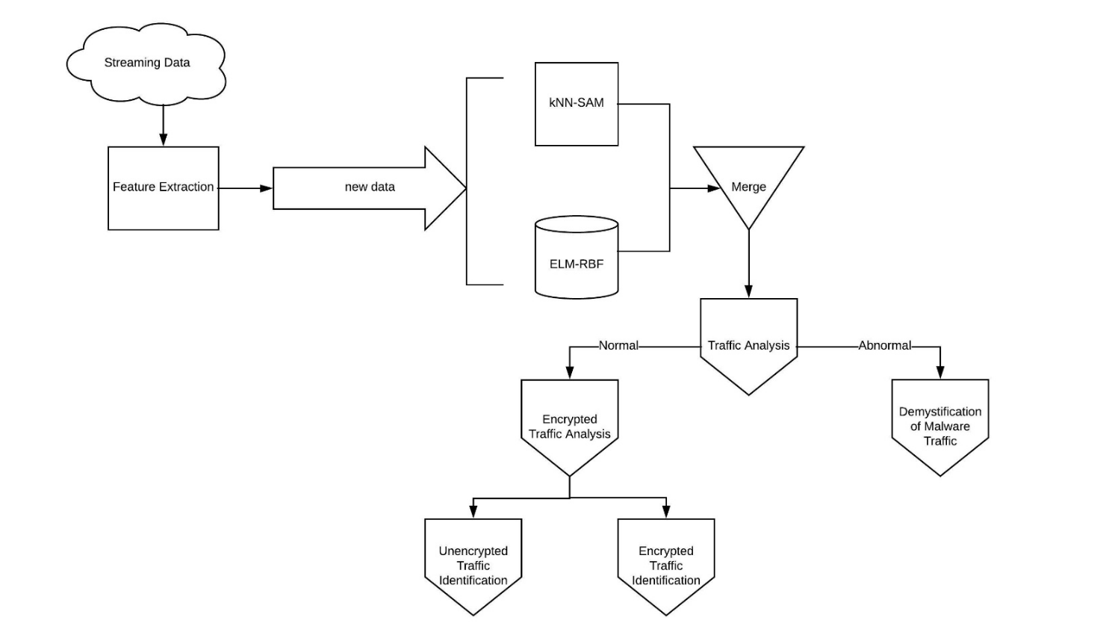

Fig 2.2.2 The algorithmic process of the proposed λ-NF3

**2.2.3 ALGORITHM:**

**Inputs:** Input new network traffic data Dl

**Step 1:** % Features Extraction

Feature extraction from network flow

**Step 2:** % Make a prediction

Use the pretrained ELM-RBF classifier using Dl to produce the prediction Ml

Use the streaming SAM/k-NN classifier using Dl to produce the prediction M2

Assign weights of 0.60 to Ml

Merge the two predictions Ml and M2 into M

**Output from traffic analysis:**

if Abnormal

Malware Traffic Demystification

for a class label Botnet, Crimeware, APT, Attack, CoinMiner

else

if Encrypted

Encrypted Traffic Identification

for a class label Tor, SSH, SSLweb, SSLP2P, SCP, Skype

else

for a class label FTP, HTTP, DNS, SMTP

end if

end if

**Outputs:** Class label for each new data D1

**2.2.4 CONCLUSION:**

The most important novelty of λ-NF3 is the proposal of the construction of a NGC2SOC [48] that uses cognitive analytics systems and sophisticated artificial intelligence tools to face real time cyber security incidents with minimal human intervention. In addition, an innovation of the λ-NF3 method is the use of the proposed lambda architecture. This framework uses a versatile and efficient intelligent-driven algorithm for batch processing and a novel evolving learning mechanism for streaming process, to solve an extremely complicated cybersecurity problem. A basic innovation of this methodology is the combination for the first time in a hybrid machine learning framework the ELM/GRBFK and SAM/k-NN algorithms. The combination offers high learning speed, ease of execution, minimal human involvement and minimum computational power and resources for network traffic analysis, demystification of malware traffic and encrypted traffic identification. Finally, the datasets, developed after protracted and extensive investigation on the network protocols, work in the lower layers (transport, network and data) and the higher layers (session, presentation and application) of the system. It is important also to note that the dataset is developed after evaluations concerning the restrictions of their characteristic performance of those protocols and the purpose of their normal or abnormal behavior in a real networking environment.

**2.3 A COMPREHENSIVE FRAMEWORK FOR CYBER BEHAVIORAL ANALYSIS BASED ON A SYSTEMATIC REVIEW OF CYBER PROFILING LITERATURE.**

**Melissa Martineau, Elena Spiridon and Mary Aiken**

**2.3.1 INTRODUCTION:**

The internet has become a space for the proliferation of criminal activity where protective guardianship is lacking. Cyberspace, and more specifically the Dark web, has become a productive domain for malicious threat actors, from hackers to organized cybercriminals, as perpetrators who use their knowledge of computer systems for personal profit or to wreak havoc. While the cybersecurity industry has an important role to play in preventing cybercrime through target hardening (e.g., anti-virus, anti-spyware), the legal response to cybercrime falls to law enforcement agencies. It is evident that cyberspace is a frontier that poses a wide range of security and law enforcement challenges. In 2021, one in ten businesses in Canada were impacted by ransomware yet only 10% of these businesses reported the crime to law enforcement. In their Cyber Threat Assessment 2023–2024, the Canadian Centre for Cyber Security (CCCS) assessed that cybercrime poses a sophisticated threat to Canada. In May of 2021, the White House issued an “Executive Order on Improving the Nation’s Cybersecurity”. The Federal Bureau of Investigation received 2.76 million complaints of cybercrime from 2017 to 2021, with the number of complaints increasing year to year. The global cost of cybercrime in 2021 was estimated at USD 6 trillion. Cybersecurity researchers estimate that this amount will increase to USD 10.5 trillion by 2025. A multi-faceted law enforcement strategy is imperative in order to disrupt cybercriminals, and in doing so, curb the rate of cyber victimization. However, the development of law enforcement strategies to address cybercrime has lagged behind advancements made in the cybercriminal underground. In general, the law enforcement approach to cybercrime to date has been technologically centric. Much effort has been expended to develop effective digital forensic tools and protocols and to train law enforcement personnel in their use. The National Institute of Standards and Technology defines digital forensics as “the process used to acquire, preserve, analyze and report on evidence using scientific methods that are demonstrably reliable, accurate and repeatable such that it may be used in judicial proceedings” (p. 24). While establishing probative digital evidence is imperative to any cybercrime investigation, cybercrimes, like their traditional counterparts, are the result of human activities based on human motives. Notably, socially engineered attacks constitute 98% of all phishing and data breach cybercrimes. Therefore, the attack vector should arguably be considered primarily psychological as opposed to purely technological. According to Turvey (p. 286), “historically, no matter what objective a technology is designed to achieve, and no matter what intentions or beliefs impel its initial development, technology is still subordinate to the motives and morality of those who employ it”. It is, therefore, important that any comprehensive law enforcement strategy for combatting cybercrime includes a deeper understanding of the individuals perpetrating the crimes and their motivations. Academia, industry, and private cybersecurity companies have devoted some attention to understanding these individuals by means of, for example, hacker typologies. By and large, however, the efforts of these groups have been to understand attack vectors and technical vulnerabilities in order to develop target hardening activities. Recently, however, there has been recognition among cybersecurity specialists of the importance of profiling not only the technical threat but also the threat actor. Arguably, the law enforcement response to cybercrime should similarly involve a human-centric psychological component (i.e., cyber behavioral analysis) as well as a digital forensic and computer science component. The application of behavioral analysis to cybercrime, however, is still in the early-stage development.

**2.3.2 SELECTION PROCESS:**

The selection of articles was accomplished using an iterative process of applying the inclusion criteria. Initially, the article titles were reviewed, followed by a review of the article abstracts. The full texts of all articles appearing to meet the inclusion criteria were obtained after the initial title and abstract reviews were performed. The full text of each article was reviewed, and the inclusion criteria applied. Attention was also given to the reference list of each included article in order to identify additional articles that were appropriate for inclusion. To maintain a rigorous systematic process, 25% of the articles included based on the article abstract and 25% of those included based on the full text were reviewed by an independent reviewer. The final article inclusion was based on consensus between reviewers.

**2.3.3 DATA COLLECTION PROCESS:**

Data collection was informed by previous systematic reviews relating to criminal profiling in order to enable a comparison of the findings. The data collected were also determined by the aim of this review to establish the foundation for a comprehensive framework for cyber behavioral analysis. A data extraction spreadsheet was used to guide the retrieval of relevant data from the selected articles. The data collection protocol included both high-level descriptive data for each included article, as well as more in-depth information regarding the study’s purpose and how the study contributed to a deeper understanding of cybercriminals and informed cybercriminal profiling.

**2.3.4 Differentiating Cybercriminals from Non-Cybercriminals:**

Foundational to being able to apply criminal profiling approaches to cybercrime is an understanding of what makes cybercriminals different from non-cybercriminals and from individuals who commit offences in the physical world. In his dissertation, Rogers conducted exploratory research focused on establishing the differences between individuals who engage in cybercrime and those who do not. Grounded in social learning and moral disengagement theories, Rogers found that individuals who committed cybercrime had higher levels of differential association, differential reinforcement, and moral disengagement than individuals who did not engage in such activities. Interestingly, the author found no significant differences between computer criminals and general criminals in relation to demographics, with the exception of race. Similarly, Young et al found that among their sample of 127 individuals attending DefCon, a popular conference for hackers held in the US, illegal hackers (n = 54) had significantly higher levels of moral disengagement. Young et al also found that while illegal hackers’ perception of the severity of punishment for hacking was higher than that of others surveyed, illegal hackers perceived a significantly lower likelihood of getting caught for their illegal activities. This may in part be explained by the work of Bachmann. In a study of 124 individuals who attended a hacker conference in the US, it was found that hackers had a significantly higher than average rationality value and a higher risk propensity than the general public. The most successful hackers, however, were the ones who preferred analytic-rational approaches to thinking but had a lower propensity for risk. This preference for rational thinking may in part explain why hackers perceived a significantly lower likelihood of getting caught. Arguably, given the low rate of reporting of cybercrime, a rational cybercriminal may assess that the potential for personal gain or fulfillment outweighs any risk. In an effort to further elucidate the differences between cybercriminals and non-cybercriminals, as well as among the different types of cybercriminals, Seigfried-Spellar and Treadway studied a sample of 296 undergraduate students with diverse majors at a university in the southern United States. Among the 296 undergraduates, 60% self-reported having committed some form of cybercrime. These respondents reported engaging in hacking (57%), identity theft (13%), cyberbullying (23%), and virus writing (8%), with 47% of the hackers reporting engagement in one of the other types of cybercrime. Seigfried-Spellar and Treadway found no significant differences in study majors or personality characteristics among those engaged in computer crime and those not engaged in computer crime. The authors were able to identify predictors for the different types of cybercrime, which are reported in the next section. Kranenbarg et al applied a novel approach to differentiating cybercriminals from general criminals by examining whether different events over the courses of their lives led to one form of crime over the other. Using police and registry data in the Netherlands from 2000 to 2012, the authors found that household composition effects for cybercrime were in the same direction as those for traditional crime, only the effects were greater. Cyber criminality was much more likely when a person lived in a single parent household than when the same person lived alone. Having a job reduced the odds of an individual committing cybercrime or traditional crime by 10% and 7%, respectively. For those employed in IT, the opposite results were found. It increased the odds of committing cybercrime by 14%, whereas it decreased the odds of committing a traditional crime by 11%.

**2.3.5 Predicting Cybercrime:**

A number of studies have attempted to identify the factors that may predict cybercrime. Gordon and Ma focused on factors that impact the intention to hack. They found that moral obligation and self-efficacy were significant predictors, with moral obligation showing the strongest negative effect. Based on their research, Gordon and Ma concluded that hackers “tend to be self-motivated and self-centered individuals; they are not likely to be easily influenced by friends or family members”. In their study of 77 university students, Rogers, Seigfried and Tidke found that only extraversion was predictive of cybercriminal behavior. The findings of this study were at odds with those of other studies (including by the same lead author) in which no significant relationship between extraversion and cybercriminal behaviors was reported. In their study of 381 Canadian university students, Rogers, Smoak and Liu found that computer-related deviant behavior was negatively correlated with internal and social moral choices and positively correlated with exploitive manipulative amoral dishonesty. In his dissertation research, Crimmins tested the predictive model presented in using a more diverse sample of college students. Crimmins found that internet addiction and openness to experiences were significantly related to computer criminal behavior. No significant correlation was found between the amount of time spent online and computer criminal behavior. Unlike Rogers, Seigfried and Tidke, Crimmins found no significant relationship between cybercriminal activities and extraversion, nor did he find a relationship with manipulative/exploitative behavior or morality. Crimmins concluded that so called “internet addiction” is the best predictor for computer criminal behavior in college students. Seigfried-Spellar and Treadway argued for the importance of recognizing the heterogeneity among cybercriminal groups and to discriminate among groups when conducting research. These researchers found differences in the personality factors that predict different types of cybercriminal activities. A low score on agreeableness was a moderate predictor for hacking. The best predictors for distinguishing between identify and non-identity thieves were high scores on neuroticism and low scores on internal moral values. The best predictive model for virus writers was a low score on moral values. However, cyberbullies were predicted by high scores on neuroticism and low scores on internal values.

**2.3.6 CRIMINAL PROFILING AND CYBERCRIME:**

Coutourie appears to be the first author to propose the usefulness of criminal profiling in cybercrime investigation. Coutourie recognized the need to slightly adjust the practice of criminal investigative analysis (CIA) to account for the differences between an interpersonal crime occurring in physical space and a cybercrime occurring in virtual space. Over the years, a number of authors have advocated for the use of criminal profiling in cybercrime investigations. Bongradt, a former FBI agent, argued that modern criminal profiling requires an understanding of how an offender interacts in cyberspace. In 2004, Bednarz recognized the work of Marcus Rogers in the development of a cybercriminal classification framework but concluded that profiling cybercriminals is a “promising but immature science”. The main issue for advancing cyber profiling, according to Bednarz, is the lack of comprehensive data on cybercriminals. This is a sentiment that has been echoed by others. A number of authors have taken an existing approach to profiling and attempted to apply that approach to cybercrime. For example, Nykodym, Taylor and Vilela provided an overview of behavioral evidence analysis (BEA), a profiling method developed by Brent Turvey. The authors concluded that it is more difficult to profile cybercrimes than traditional crimes. Despite the perceived difficulty, many authors see value in integrating criminal profiling into cybercrime investigations. Casey and Turvey, in their book chapter Investigative reconstruction with digital evidence, provided the reader with an overview of BEA and how this approach to profiling can be applied to cyber investigations. Particular attention was paid to the reconstruction of cybercrime based on an equivocal forensic analysis, a phase in BEA whereby the profiler/investigator examines the evidence looking for behavioral imprints. Behavioral imprints are clues into the offender’s personality, modus operandi, and motivation. Balogun and Zuva also proposed a model for profiling cybercrime with a foundation in behavioral evidence analysis. The framework put forth by these authors more fully integrated digital forensics into the reiterative profiling process. The authors argued that this model should be applicable to profiling of all forms of cybercrime. In fact, there are a number of authors who have argued for an integration of criminal profiling and digital forensics, that is, the process of identifying, extracting, analyzing, and reporting digital evidence. In fact, Lickiewicz argued that computer security specialists have taken an interest in integrating an understanding of the cybercriminal into their threat modeling because the offender is the only stable element in the investigation. Disciplines such as cyberpsychology have adopted an integrated research approach. Cyberpsychology is the study of the impact of technology on human behavior, covering a range of research fields from internet psychology to artificial intelligence. A reference to the emerging sub-discipline of forensic cyberpsychology first appeared in Europol’s 2014 Internet Organised Crime Threat Assessment Report, noting that “the critical task for cyberpsychology as a discipline is to build up a body of established findings of how human beings experience technology, the critical task in forensic cyberpsychology is to focus on how criminal populations present in cyber environments”. In their conference paper, Kwan, Ray and Stephens differentiated between cybercrime and cybercriminal profiles. The former is created through the process of digital forensic analysis and focuses on the technical elements of cybercrime. The latter, the authors argued, can be developed based on the developed cybercrime profile. The authors did not explicitly state how one would develop the cybercriminal profile from the cybercrime profile. There is recognition of the value of engaging multi-disciplinary teams to contribute to the process of profiling cybercriminals. A recent pan-European research project regarding human and technical drivers of cybercrime applied such a multi-disciplinary approach by incorporating a wide range of disciplines, including psychology, criminology, anthropology, neurobiology, and cyberpsychology. Casey argued that the early application of profiling to cybercrime investigations can help inform the digital forensic process (i.e., what evidence can be expected to be found and where). Some authors have proposed the automation of profiling methods to deliver cybercrime profiles, although it is unclear how this automation would occur or if it would be capable of addressing all aspects of behavioral analysis. In his dissertation research, Sutter examined whether there is a connection between cyber attacker actions and human behavior. Using investigative psychology and the work of David Canter as his framework, Sutter used smallest space analysis (SSA) to explore how the technical actions in a cyberattack may cluster and align with human behavioral sub-types identified through research on burglary. While Sutter found that the attack actions did cluster into identifiable facets, these facets could not be aligned with a single behavioral typology. Sutter suggested that the use of SSA to profile cybercrime may not be appropriate.

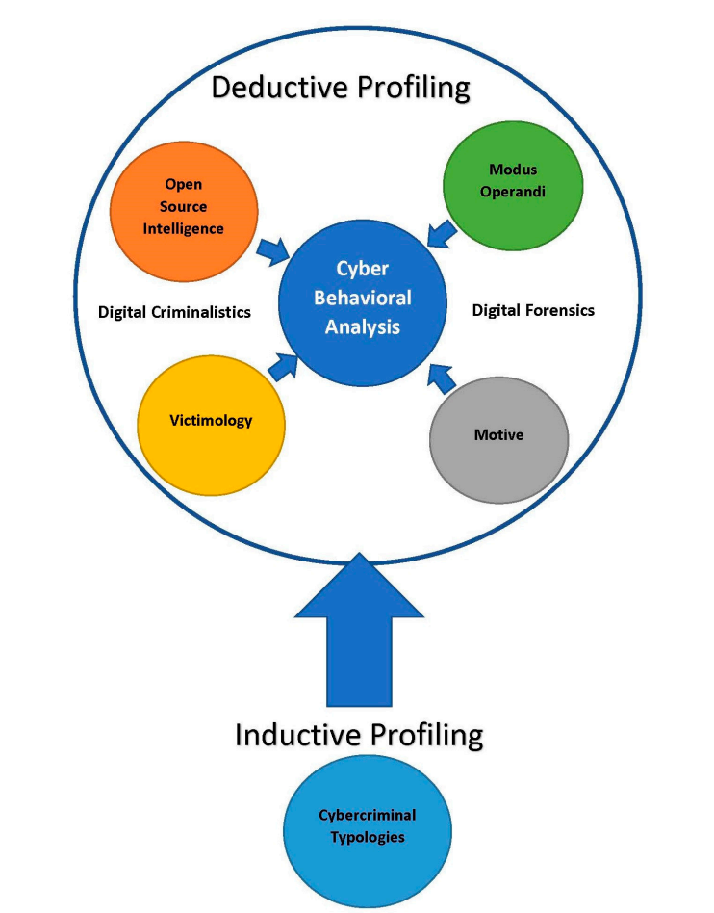

Fig 2.3.1 Framework for Cyber Behavioral Analysis.

**2.3.7 CONCLUSION:**

Despite four decades of research focusing on cybercriminals, the state of the literature remains at an early stage. Much of what we currently know about cybercriminals stems from the works of authors who provided accounts of the development of the hacker culture or research using proxy samples. The research is heavily weighted with literature reviews and discussion pieces by authors who are not regularly conducting empirical research or contributing new works to the field. The lack of more complex research using primary data and the dearth of a concerted effort by experts to advance knowledge in the field has resulted in limited development. Technology is a field of constant advancement. This constant advancement has led to heterogenous groups of cybercriminals who are adapting new techniques, tactics, and protocols at a considerable pace. Understanding these criminals necessitates a continuous research effort. Hacker typologies that were proposed two decades ago may not adequately reflect today’s cybercriminals, just as the typologies developed today may have little relevance to the ever-evolving cybercriminals of tomorrow. This systematic review led to the proposal of a new framework for the application of profiling to cybercrime. Future research efforts should include an evaluation of how this framework performs when applied to cybercrime investigations. The intention of proposing this framework was to consider the existing approaches to profiling and the role that digital forensics may play in the profiling process. CBA incorporates elements of the various approaches reviewed as well as digital forensics to provide a more comprehensive approach to cyber profiling. Cyberspace could be considered as an almost unintended virtual world emanating from a project to enable military communication and it has been created at a breakneck pace. Cyberspace has become an environment populated by humankind that we now must find a way to secure, in the same way that people are protected in the real world. Law enforcement is faced with the considerable challenge of keeping pace with the adoption of new technologies in order to investigate crimes that take place in the digital world of cyberspace. Advancements in digital forensic analysis have equipped law enforcement with improved methods of identifying, acquiring, and analyzing evidence found on devices. Effective investigative strategies, however, cannot exclusively focus on the technical aspects of cybercrime. An understanding of the human perpetrators behind the keyboard is essential. This is where CBA can contribute to cybercrime investigations and where the utility of emerging disciplines such as cyberpsychology and forensic cyberpsychology will undoubtedly prove to be invaluable. The efficacy of CBA rests in the use of a systematic approach that is empirically based and integrates digital forensics.

**2.4 A DIGITAL TWIN-BASED CYBER RANGE FOR SOC ANALYSTS**

**Manfred Vielberth, Magdalena Glas, Marietheres Dietz, Stylianos Karagiannis, Emmanouil Magkos, and Gunther Pernul**

**2.4.1 INTRODUCTION:**

As cyber-attacks become increasingly sophisticated and use more and more points of attack, it is essential to establish a holistic view of organizations’ security. As a recently published report indicates, organizations are becoming better at detecting and mitigating direct attacks. However, more advanced attacks are on the rise, targeting the victim indirectly through weak spots in the business ecosystem or the supply chain. Over the recent years, Security Operations Centers (SOCs) have emerged to address this problem by providing a holistic view of organizations’ cybersecurity. However, this has increased the demand for security personnel, making it difficult to find enough well-trained analysts for SOCs. This is worsened by the so-called “alert burnout”, since an analyst’s daily work can be quite tedious and tiring. According to a SANS survey, the key to low attrition rates is to invest more in analysts’ training. Therefore, it is crucial to create a means to train analysts as quickly and effectively as possible, considering that the requirements can vary from company to company. To create a suitable training environment, cyber ranges can be used to train analysts by simulating realistic scenarios without disrupting business operations. To be as close as possible to the specifics of the company, the integration of a digital twin is a promising option. Thereby, the relevant of the company infrastructure for which the experts are to be trained can be mirrored, creating a training environment that barely differs from the company’s real environment. The contribution of this paper is twofold. First, we examine which components of a digital twin can be used for cyber ranges. Based on this, a cyber range for SOC analysts is designed and prototypically implemented. To show that the proposed concept offers advantages for the training of security analysts, it is evaluated through an extensive empirical user study. The remainder of this paper is structured as follows. This provides the foundation of the conducted research. In the digital twin’s potential for cyber ranges is outlined along with the current research gap. Based on that proposes a concept for a digital twin-based cyber range, including a scenario and learning concept and concludes with a description of the prototypical implementation of the concept. The evaluation of the concept in the form of a comprehensive user study by presenting the methodology and the results of the evaluation.

**2.4.2 SECURITY OPERATIONS CENTER (SOC):**

The term Security Operations Center has been around in research for more than a decade. However, attention has significantly increased in the last three to five years as SOCs have emerged as a central pivotal point for security operations in practice. The SOC represents an organizational aspect of an enterprise’s security strategy. It combines processes, technologies, and people to manage and enhance an organization’s overall security posture. This goal can usuall not be accomplished by a single entity or system, but rather by a complex structure. It creates situational awareness, mitigates the exposed risks, and helps to fulfill regulatory requirements. Additionally, a SOC provides governance and compliance as a framework in which people operate and to which processes and technologies are tailored. A central role within a SOC is taken by security analysts. Using appropriate tools, they can attempt to detect security incidents, then analyze them and react appropriately. Therefore, the success of a SOC depends to a large extent on the skills and training of the analysts. Within a SOC, a SIEM system is usually used as the central tool. A SIEM aims to collect security-relevant data (usually log data) in a central location and analyze it in a correlated manner to detect security incidents. For this purpose, SIEM systems use detection rules that are usually created by analysts, in most cases in JSON or XML format. These fulfill the purpose of triggering an alert if defined conditions within the log data apply.

**2.4.3 DIGITAL TWIN:**

The digital twin refers to a concept that differs in meaning depending on its application area. In general, a digital twin can be defined as a virtual representation of any real-world asset (e.g., system or process). The digital twin accompanies its real-world asset’s lifecycle, which may range from phases like idea/planning over operation to decommissioning. The digital twin gathers data about its real-world twin during these phases and enriches the data with semantics. This way, the twin is able to represent its counterpart in-depth and provides a solid basis for simulations and further analytical measures. Especially in cybersecurity, the digital twin holds several benefits. It can support lifecycle security, including the security-by-design paradigm by offering simulations and system testing, in which the security level of the asset can be assessed. Moreover, digital forensics may profit from the vast data and documentary capabilities of a digital twin.

**2.4.4 CYBER RANGE CONCEPT:**

Our cyber range consists of five main building blocks A virtual environment, a SOC, a management and monitoring unit, a learning management system, and the digital twin, which lies outside of the cyber range. Thus, it represents a security analytics service combined with cyber range specific components. In the following, these building blocks are explained in more detail.

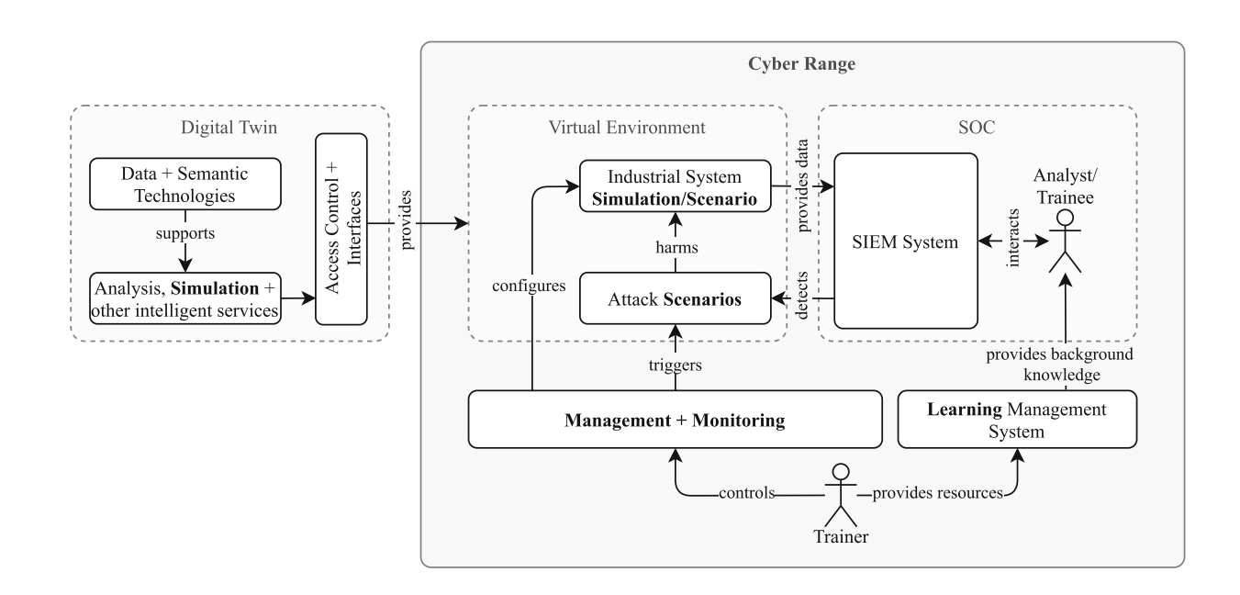

Fig 2.4.1 Basic concept of the digital twin-based cyber range for SOC analysts.

The virtual environment implements and reflects the scenario of the cyber range through the simulation. For this purpose, an industrial system is simulated on the one hand and simulated attacks harming the industrial system are carried out on the other. Thereby, the planned training scenario is reproduced, guiding the trainee through several training units similar to a playbook, elaborated. In the process, the simulated industrial system produces log data documenting its operation and providing traces pointing to the attack scenarios. Within the SOC building block, a SIEM system is provided, which provides the actual point of interaction with the trainee. The SIEM represents the system for which an analyst is trained, and ideally is also a system in practical use in the trainee’s organization. This ensures that the trainee learns to work with a system that is as close to the real SIEM as possible or even identical to it. The log data of the industrial system is fed into the SIEM. In the first step, the trainee interacts with the SIEM to analyze and manually detect the simulated attacks based on the available data. In the next step, the trainee can use this to create correlation rules in the SIEM, which detect attacks automatically. The learning management system (LMS) provides additional learning material for the trainee and introduces the scenario. This information can be presented in various forms, such as videos or simple textual descriptions. In our case, an introduction to the functioning of SIEM systems and the structure of SIEM rules is provided. In addition, hints on the attacks are given to make it easier to get started using the SIEM. These materials are prepared by the trainer and are included in the LMS so that they can be accessed during the procedure. A more detailed description of the prepared media is given. With the help of the management and monitoring building block, the trainer can oversee the trainees’ progress during training. Additionally, it configures the simulation of the industrial system and automatically triggers attack simulations depending on the progress of the training.

**2.4.5 IMPLEMENTATION:**

The overall architecture of the cyber range is shown. To simulate the industrial system, the digital twin’s simulation component is transferred to the cyber range to create a realistic virtual environment. The simulation is realized with MiniCPS, an academic framework for simulating cyber-physical systems which builds upon Mininet. To monitor the network traffic, a firewall captures the TCP-traffic within the network and detects certain abnormalities such as ambiguous responses to ARP-requests. The firewall functionalities are implemented with scapy. The PLCs and the HMI produce system logs on the main functions of the filling process and the firewall monitoring, which are stored as log files in a common logs directory.

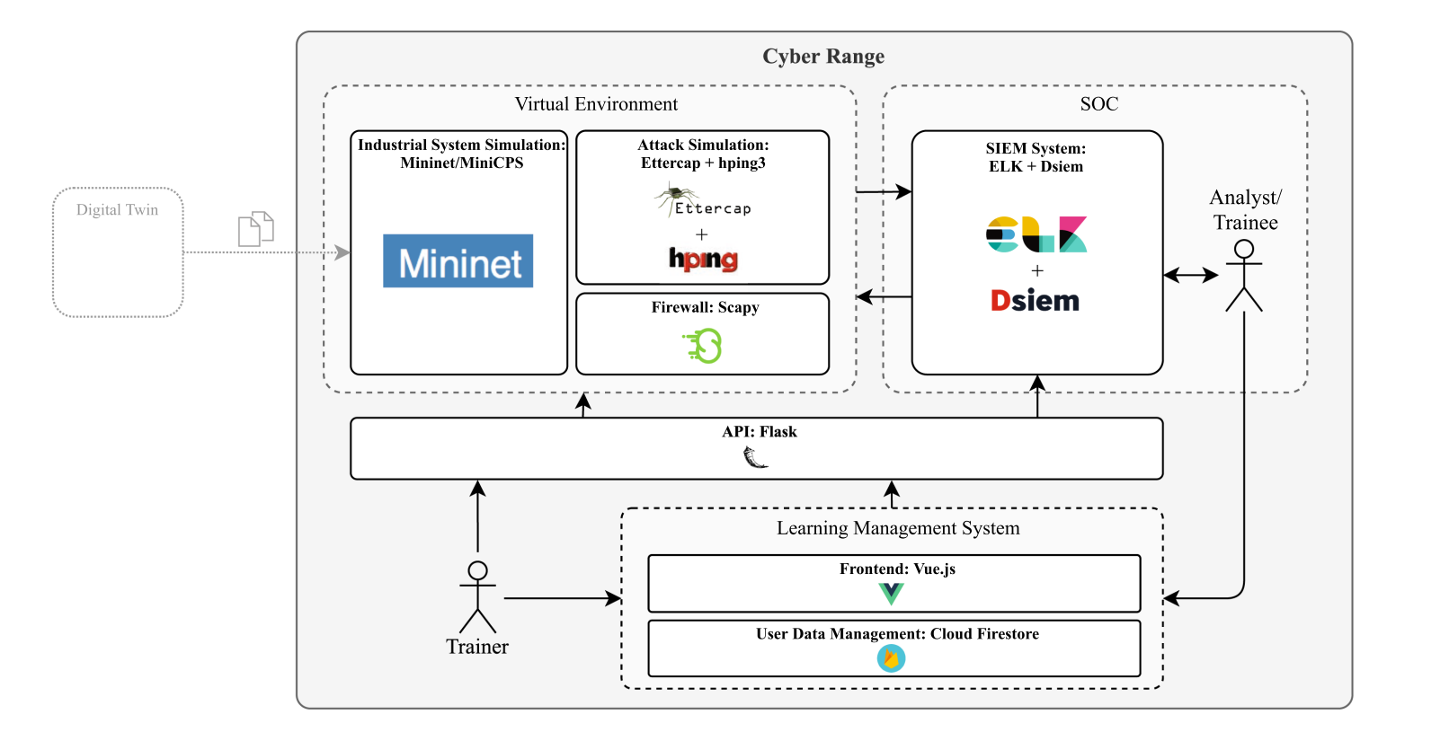

Fig 2.4.2 Architecture of Implementation

As the cyber range concept should not only lead to an increase of knowledge but also provide a positive learning experience, the training aims to attract the participant’s attention and provide a high level of engagement. Metrics for measuring the engagement levels of the participants are provided by Keller’s ARCS model of motivational design which has been used in the past to evaluate security and privacy educational approaches before. It focuses on the intrinsic attributes enhancing motivation, and includes metrics that relate to Attention, Relevance, Confidence, and Satisfaction. The ARCS model can be extended by an extra metric for perceived learning, which measures the subjective impression of whether learning has occurred. This part of the evaluation was implemented by constructing a feedback questionnaire based on the ARCS model, extended by the perceived learning condition. Thereto, the participants can indicate the degree of agreement to 16 statements, with a Likert scale ranging from 1 to 5 (“completely disagree” to “fully agree”) after the training.

**2.4.6 CONCLUSION:**

This work demonstrates how cyber ranges can be utilized for training security analysts in a SOC. It shows that cyber ranges are suitable for the acquisition of general knowledge about SIEM as well as for specific training on how to create SIEM rules. The provided cyber range concept builds upon the simulation component of a digital twin of an industrial filling plant. This ensures that the analysts are trained based on a realistic scenario. To show the increase in knowledge and the perceived learning experience, the concept is implemented and evaluated in an international study among both Greek and German participants. To the best of our knowledge, this is the first cyber range to utilize the potential of a digital twin, specifically targeting the training of SOC analysts. Like any other research effort, this paper contains limitations. Since, to our knowledge, no approach with the same objective exists, it was not possible to compare the knowledge gains. However, we were able to show that a cyber range is, in general, suitable for imparting knowledge. Nonetheless, we did not concentrate on an evaluation comparing our cyber range to other concepts. In summary, this work provides a new approach to train SOC analysts. By proposing security training, it addresses the current problem of the increasing demand for security analysts personnel, which will continue to grow. Furthermore, the attack detection training of SOC analysts is only one of many possible applications of the presented cyber range. Among many other possibilities, it could also be used for penetration testing of industrial plants or incident response exercises in future research.

**2.5 DESIGNING SIMULATION LOGIC OF CYBER OPERATION USING CYBER SECURITY FRAMEWORK**

**Sangjun lee and dongsu kang**

**2.5.1 INTRODUCTION:**

The explosive growth of information system operations has emphasized the importance of cybersecurity, and the role of strategic cybersecurity has recently increased at the national level. The Government of the Republic of Korea is promoting "fostering 100,000 cybersecurity talents" as a core task of cybersecurity and is exploring various ways to provide effective cyber education and training to them. However, most of the existing training models are conducted only in red teaming method, which may be suitable for improving the technical skills of individual cyber professionals, but training that is not connected to other departments or organizations that use real information systems cannot achieve the common goals of an enterprise. Therefore, while it is necessary to explore the role of cybersecurity in the overall organization's operations through simulation training, it is hard to find any training models that simulate cyber operations. In order to overcome these limitations of existing cyber operation training, this study proposes a simulation logic that can contribute to the improvement of cyber operation capabilities by designing a cyber operation execution procedure that can be simulated in the training model based on the cyber security framework. This paper is organized as follows introduces the CSF and existing research on how to assess the impact of cyberspace activities on physical space. In this, we design a procedure to simulate cyber operations in a training model, and in this we present a training case to simulate the damage caused to physical space by a cyberattack.

**2.5.2 CYBER SECURITY FRAMEWORK (CSF):**

With the enactment of the U.S. cybersecurity enhancement act (CEA) in 2014, the National Institute of Standards and Technology (NIST) first published the CSF and it is still continually updated. Rather than being prescriptive, the CSF is designed to be a set of standards, guidelines, and best practices that organizations can operate on a voluntary basis. It is the most widely adopted security framework for organizations and government agencies in the US and abroad because of its flexibility to integrate with existing security processes in any industry. As a baseline for assessment, the CSF can be used to measure the maturity of a cybersecurity program since its creation, or to recognize the safety of an organization's infrastructure by demonstrating compliance. NIST defines the CSF in five phases for standardized risk management in cyberspace, as follows:

**1) Identify:** Develop an organizational understanding to manage cybersecurity risk to systems, people, assets, data, and capabilities.

**2) Protect:** Develop and implement appropriate safeguards to ensure delivery of critical services.

**3) Detect:** Develop and implement appropriate activities to identify the occurrence of a cybersecurity event.

**4) Respond:** Develop and implement appropriate activities to take action regarding a detected cybersecurity incident.

**5) Recovery:** Develop and implement appropriate activities to maintain plans for resilience and to restore any capabilities or services that were impaired due to a cybersecurity incident.

For organizations to understand cybersecurity from a strategic perspective, these five functions should be treated as key criteria. Considering them simultaneously and always within the risk management lifecycle can help protect the critical assets your organization manages.

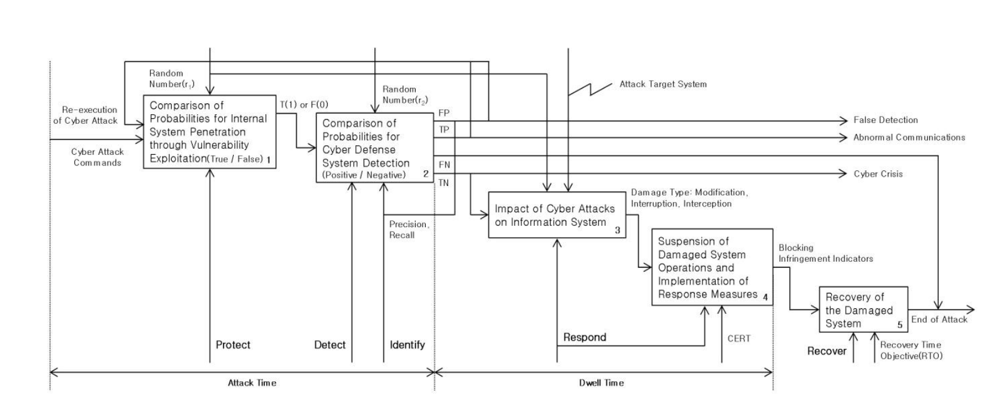

Fig 2.5.1 Cyber operations for cyber training system

**2.5.3 THE SIMULATION LOGIC OF CYBER OPERATION:**

The procedure for performing cyber operations based on CSF is shown in Fig. 4. In the training model, we define the adversary simulating a cyberattack on the target system as ‘attacker’ and the user of the training model as ‘trainee’. The defense range of the trainee is assumed to be composed of the internal network, cyber defense system, and information system. First, when the attacker launches an attack on the network, it encounters an obstacle: the internal network. If the attacker succeeds in penetrating the internal network because the network is not well protected against vulnerabilities, it is classified as “True (T),” and conversely, if the attacker fails to penetrate the internal network, it is classified as “False (F).” After that, the attacker goes through the cyber defense system before entering the information system, and if the cyber defense system detects the situation of the attacker's penetration, it is classified as “Positive (P),” and if the situation goes un detected, it is classified as “Negative (N),” and the abstract procedure can be concretized as an IDEF.

Protect is the phase where the attacker compares the probability values of exploiting the vulnerability to penetrate the system. The internal system penetration simulation procedure compares the first random number (r1) calculated earlier with a pre-set probability value to distinguish between a successful penetration (T) and a failed penetration (F), in which the probability value can be calculated using a probabilistic Lanchester Stochastic combat model based on the concept of conditional probability. The probability of a change in the trainee's force under the condition that a change in the battle state has occurred can be expressed and the probability of a change in the attacker's force can be expressed.

Detect is a probabilistic comparison of whether the trainee's cyber defense system can detect the attacker's attack. The second random number (r2) previously calculated and the probability value are calculated, and if reaching the probability value, the situation is simulated as the success of detection (P), but if the probability value is not reached, the situation is simulated as failure of detection (N).

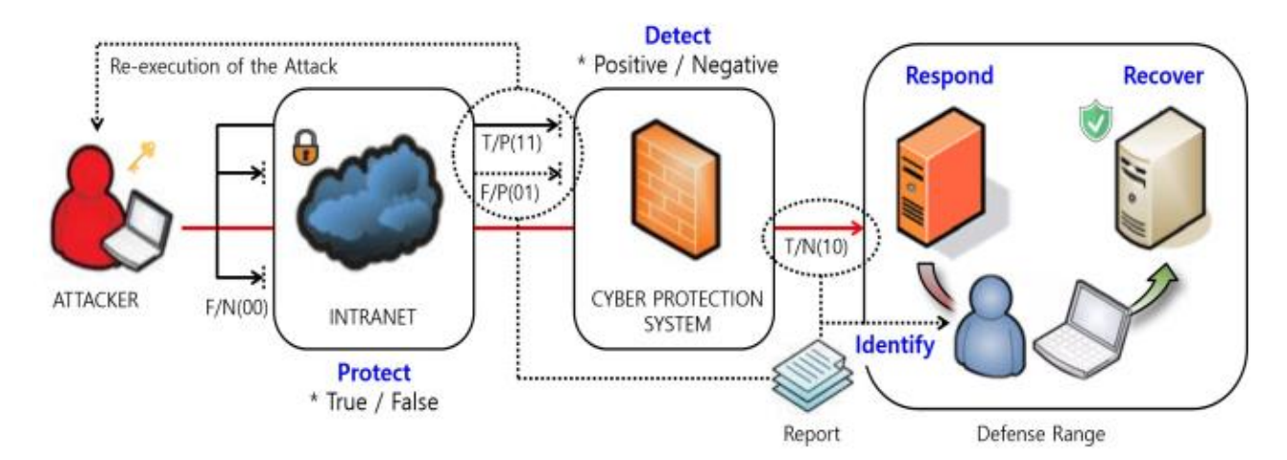

Fig 2.5.2 Cyber operations for cyber training system

To achieve absolute superiority in asymmetric warfare, North Korea has established the concept of "Computer Warfare" and employs tactics to force the enemy to waste time on prevention and treatment through cyberattacks of extracting data, injecting data, or slowing down operations using malicious software (SW) before or during military actions. These adversary cyberattacks will be conducted to destroy the three goals of information security: confidentiality, integrity, and availability. The types of damage will be categorized into passive attacks of interception, active attacks of modification, and interruption based on the core elements of information security and the adversary's strategies. Since it is challenging to simulate a series of activities that occur within a virtual cyberspace, the training model indirectly simulates the impact of the attacker's cyberattack on physical space, such as the Iranian "Stuxnet" case, where the victimized system in physical space becomes the attacker's attack target. Based on the cyber crisis judgment generated, the trainee reports the damage status to CERT, and CERT blocks the infringement indicators (harmful IP / URL) and reports the results back to the trainee, and the affected system is put into a suspended state for investigation and analysis. This procedure can be used as a dwell time for the damage caused by the attacker's cyberattack in the training model.

As the final phase of the CSF, NIST divides the concept of recovery into a strategic recovery phase and a tactical recovery phase. Unlike strategic recovery, which prepares a recovery plan for future predicted incidents based on lessons learned after an incident, tactical recovery is the phase of recovering from an incident according to a self-developed scenario, and it needs to be applied to defensive cyber operations activities because it is essential to ensure the availability of information systems in times of crisis and to find alternative means. To do this, it is necessary to evaluate the downtime tolerance of the system being recovered, which is the recovery time objective (RTO) for resuming service for each process after a failure. The general disaster recovery system divides the recovery level into four types Mirror Site, Hot Site, Warm Site, and Cold Site and grants different time RTOs according to the server operation method ,However, since the response measures and recovery time may vary depending on the size and complexity of the cyberattack and the security status of the target system, each measure and recovery time are only general guidelines and need to be adjusted to suit the actual situation, Additional consideration should be given to contingencies that may occur between operations. The information system damage recovery time that can be performed in a typical environment can be presented by task by linking the data of the time required to respond to a breach during cyber operations activities with the moving time that a traditional CERT must move to recover the recovery levels classified by type damage.

**2.5.4 CONCLUSION:**

This paper designed a procedure to simulate cyber operations in the simulation training model and proposed how to utilize it to train the phases to respond to and take action on the visible damage caused to the physical space by cyberattacks. The proposed method first applies Monte Carlo simulation based on the cyber risk management model to model uncertain situations in cyberspace with probabilistic techniques. Two random numbers are generated by the Mersenne twister random number generation algorithm. And they applied to the detection probability of the cyber defense system using the Lanchester Stochastic combat model with the military strength ratio of cyber capabilities and the threshold-based anomaly detection method. The results of the cyberattack and the defensive cyber operation of the trainee are classified with a confusion matrix. Based on the classified results, the trainee was notified of the occurrence of a cyberattack, while the attacker was simulated to receive either permission to re-execute a failed cyberattack or to show the impact of damaging the information system that was the target of the attack in the physical space with a successful attack. After the impact, an operational cycle is formed by simulating the damage recovery process using a concept that combines the response measures using the CERT and the time required for the necessary tasks to normalize the simulated system. It is expected that the proposed simulation procedure can be used for the military disciplines applied in the command training program of the cybersecurity training models and the logic for simulating the effects of cyber operations in cyber-physical system and strategy simulation games.

**CHAPTER-3**

**EXISTING SYSTEM**

**3.1 SPLUNK:**

**3.1.1 DESCRIPTION:**

Splunk is a leading real-time Security Information and Event Management (SIEM) platform that enables organizations to collect, index, search, and analyze large volumes of machine generated data from various sources in real-time. Originally developed as a log management and analysis tool, Splunk has evolved into a comprehensive data analytics platform used for security, IT operations, business intelligence, and more.

**3.1.2 APPLICATIONS:**

**Security Monitoring and Incident Response:** Splunk is widely used by security operations teams to monitor and analyze security events, threats, and anomalies in real-time. It provides visibility into network traffic, endpoint activities, logs, and security events, enabling proactive threat detection, incident investigation, and rapid response to security incidents.

**Threat Intelligence Integration:** Splunk integrates with third-party threat intelligence feeds to enrich security event data with contextual information about known threats, indicators of compromise (IOCs), and adversary tactics, techniques, and procedures (TTPs). This helps in identifying and prioritizing security alerts based on the level of risk.

**Compliance and Regulatory Reporting:** Splunk facilitates compliance monitoring and reporting by aggregating and analyzing log data to demonstrate adherence to regulatory requirements such as GDPR, HIPAA, PCI DSS, and SOX. It provides pre-built compliance dashboards, reports, and alerts to streamline audit processes.

**Operational Visibility and IT Monitoring:** Splunk enables IT operations teams to monitor and troubleshoot infrastructure performance, application availability, and service health in real-time. It provides insights into system logs, metrics, and events, helping in identifying and resolving operational issues quickly.

**Business Analytics and Insights:** Splunk can analyze machine data from business applications, web servers, IoT devices, and other sources to derive valuable insights for business decision-making. It helps in identifying trends, patterns, and anomalies in data to optimize processes, improve customer experiences, and drive innovation.

**3.1.3 DISADVANTAGES:**

**Cost:** Splunk licensing costs can be significant, especially for large-scale deployments or organizations with extensive data retention requirements. Additional costs may also be incurred for premium features, add-ons, and professional services.

**Complexity:** Setting up and configuring Splunk can be complex, requiring expertise in data ingestion, parsing, indexing, and search optimization. Organizations may need skilled administrators and analysts to manage and maintain the platform effectively.

**Resource Consumption:** Splunk deployments can consume significant CPU, memory, and storage resources, especially when indexing and searching large datasets in real-time. Proper capacity planning and infrastructure optimization are essential to avoid performance issues.

**Learning Curve:** SPL (Splunk Processing Language) and the Splunk platform itself have a steep learning curve for new users. Training and certification programs are available, but acquiring proficiency in Splunk may require time and investment in education and skills development.

**3.2 SNORT:**

**3.2.1 DESCRIPTION:**

Snort is an open-source Intrusion Detection System (IDS) and Intrusion Prevention System (IPS) developed by Sourcefire, now owned by Cisco. It is widely used by organizations and security professionals to monitor network traffic, detect suspicious activities, and prevent network intrusions in real-time. Snort employs signature-based detection, protocol analysis, and anomaly-based detection techniques to identify and respond to security threats.

**3.2.2 APPLICATIONS:**

**Network Intrusion Detection:** Snort monitors network traffic in real-time by inspecting packets passing through network interfaces. It analyzes packet headers and payloads to detect known attack signatures, patterns, or behaviors indicative of malicious activity.

**Intrusion Prevention:** In addition to detection, Snort can also take proactive measures to prevent intrusions by blocking or dropping malicious packets based on predefined rules or policies. It acts as an inline IPS to enforce network security policies and protect against attacks.

**Protocol Analysis:** Snort performs deep packet inspection to analyze network protocols and application layer traffic. It can identify protocol violations, unusual behaviors, and suspicious patterns that may indicate potential security threats or policy violations.

**Custom Rule Creation:** Snort allows users to create custom detection rules tailored to their specific security requirements and network environments. Users can define rules to match unique attack signatures, indicators of compromise (IOCs), or behavior patterns relevant to their organization.

**Traffic Logging and Forensics:** Snort logs detected security events, alerts, and packet captures for forensic analysis and incident response purposes. It provides detailed information about detected threats, including source and destination IP addresses, timestamps, and attack payloads.

**Integration with Security Information and Event Management (SIEM) Systems:** Snort can integrate with SIEM platforms and security orchestration tools to centralize event correlation, alerting, and incident response workflows. It enhances the visibility of network security events and facilitates automated response actions.

**Community and Rule Sharing:** Snort has a large and active community of security professionals, researchers, and enthusiasts who contribute to rule development, sharing best practices, and collaborating on threat intelligence. Users can leverage community-sourced rules and resources to enhance their detection capabilities.

**3.2.3 DISADVANTAGES:**

**False Positives:** Snort may generate false-positive alerts due to misconfigured rules, benign network activity, or limitations in signature-based detection. Tuning and refining detection rules are necessary to minimize false positives and improve detection accuracy.

Limited Visibility into Encrypted Traffic: Snort cannot inspect encrypted traffic (e.g., SSL/TLS encrypted connections) without additional decryption capabilities or integration with SSL/TLS termination devices. Encrypted payloads may evade detection, limiting visibility into potential threats.

**Complexity of Rule Management:** Managing and maintaining custom rules in Snort can be complex and time-consuming, especially for large-scale deployments or environments with diverse network architectures. Proper rule management practices and version control are essential to ensure rule effectiveness and consistency.

**Resource Consumption:** Snort deployments may consume significant CPU, memory, and storage resources, especially when processing high volumes of network traffic or running in inline IPS mode. Proper hardware sizing and optimization are necessary to avoid performance bottlenecks.

**Lack of Official Support:** While Snort benefits from an active open-source community, it lacks official commercial support compared to proprietary IDS/IPS solutions. Organizations may rely on community resources, third-party vendors, or in-house expertise for support and troubleshooting.

**3.3 CROWDSTRIKE FALCON:**

**3.3.1 DESCRIPTION:**

CrowdStrike Falcon is a cloud-native endpoint protection platform (EPP) and endpoint detection and response (EDR) solution developed by CrowdStrike Inc. It is designed to provide organizations with advanced threat prevention, detection, and response capabilities to protect endpoints from cyber threats, including malware, ransomware, fileless attacks, and advanced persistent threats (APTs). CrowdStrike Falcon leverages cloud-based architecture, artificial intelligence (AI), and behavioral analytics to deliver real-time visibility, threat intelligence, and automated response actions across endpoints.

**3.3.2 APPLICATIONS:**

**Endpoint Protection:** CrowdStrike Falcon provides comprehensive endpoint protection capabilities to prevent, detect, and block a wide range of cyber threats in real-time. It employs signature-based prevention, machine learning (ML), and behavioral analysis to identify and stop malicious activities on endpoints.

**Endpoint Detection and Response (EDR):** CrowdStrike Falcon offers EDR functionalities to monitor endpoint activities, analyze behavior patterns, and investigate security incidents in real-time. It collects telemetry data from endpoints, including process executions, file modifications, and network connections, to detect and respond to threats.

**Threat Intelligence Integration:** CrowdStrike Falcon integrates with CrowdStrike's Threat Graph, a cloud-based threat intelligence platform, to provide real-time threat intelligence feeds, indicators of compromise (IOCs), and adversary intelligence. It enriches security telemetry data with contextual information to enhance threat detection and response.

**Incident Investigation and Forensics:** CrowdStrike Falcon enables security teams to conduct forensic investigations and incident response actions on compromised endpoints. It provides visibility into endpoint events, artifacts, and attack kill chain stages to identify root causes and remediate security incidents.

**Automated Response and Remediation:** CrowdStrike Falcon supports automated response actions, such as quarantine, containment, and remote remediation, to mitigate security risks and contain threats on endpoints. It enables security teams to respond to incidents quickly and effectively without manual intervention.

**Compliance Monitoring and Reporting:** CrowdStrike Falcon helps organizations achieve regulatory compliance by monitoring endpoint security posture, enforcing security policies, and generating compliance reports. It provides insights into security events, incidents, and vulnerabilities for audit purposes.

**3.3.3 DISADVANTAGES:**

**Cost:** CrowdStrike Falcon's licensing costs can be significant, especially for large-scale deployments or organizations with extensive endpoint fleets. Additional costs may be incurred for premium features, add-ons, and professional services.

**Dependency on Cloud Infrastructure:** CrowdStrike Falcon relies on cloud infrastructure for data processing, storage, and management. Organizations may face connectivity issues, latency, or dependency risks associated with cloud services.

**Limited Offline Protection:** CrowdStrike Falcon's cloud-native architecture may pose challenges in environments with intermittent or limited internet connectivity. Endpoints may experience gaps in protection or delayed response actions during periods of network downtime.

**Complexity of Deployment and Integration:** Deploying and integrating CrowdStrike Falcon into existing security workflows and infrastructure may be complex and time-consuming. Organizations may require expertise in endpoint security, cloud architecture, and security operations to ensure successful deployment and optimization.

**Resource Consumption:** CrowdStrike Falcon's endpoint agents may consume significant CPU, memory, and network resources, especially in environments with resource-constrained endpoints or legacy hardware. Proper endpoint management and optimization are necessary to minimize performance impact.

**Vendor Lock-In:** Organizations using CrowdStrike Falcon may become locked into the CrowdStrike ecosystem, making it challenging to switch to alternative endpoint security solutions or platforms. Vendor lock-in risks should be evaluated when considering long-term investment in CrowdStrike Falcon.

**3.4 DARKTRACE:**

**3.4.1 DESCRIPTION:**

Darktrace is an artificial intelligence (AI) cybersecurity company that specializes in autonomous threat detection and response. Its flagship product, the Darktrace Enterprise Immune System, leverages machine learning (ML) algorithms and AI techniques to detect and respond to cyber threats in real-time. Darktrace's approach is based on the concept of "self-learning" AI, where the system continuously learns and adapts to evolving threats and anomalies within an organization's network.

**3.4.2 APPLICATIONS:**

**Threat Detection and Autonomous Response:** Darktrace's AI algorithms analyze network traffic, user behavior, and device activity in real-time to identify anomalous patterns, suspicious activities, and potential security threats. It autonomously responds to detected threats by taking remediation actions to contain and mitigate risks.

**Insider Threat Detection:** Darktrace's AI capabilities enable it to detect insider threats, including malicious insiders, compromised accounts, and unauthorized activities by employees or contractors. It monitors user behavior, access patterns, and data movements to identify abnormal behaviors indicative of insider risks.

**Zero-Day Threat Detection:** Darktrace's AI algorithms are trained to detect zero-day threats and novel attack techniques that may evade traditional security controls. It analyzes network traffic and endpoint telemetry to identify anomalous behaviors and indicators of compromise (IOCs) associated with unknown threats.

**Ransomware and Malware Detection:** Darktrace detects and responds to ransomware attacks, malware infections, and other types of malicious software by identifying suspicious file behaviors, command-and-control communications, and encryption activities. It helps organizations prevent data breaches and data loss incidents.

**Cloud Security Monitoring:** Darktrace extends its threat detection capabilities to cloud environments, including public cloud platforms (e.g., AWS, Azure) and Software-as-a-Service (SaaS) applications. It monitors cloud workloads, configurations, and user activities to identify security risks and unauthorized access.

**IoT Security:** Darktrace provides visibility and security monitoring for Internet of Things (IoT) devices deployed within organizational networks. It detects anomalous behaviors, communications, and vulnerabilities associated with IoT devices to prevent potential cyber-attacks and data breaches.

**Compliance and Regulatory Reporting:** Darktrace helps organizations achieve regulatory compliance by providing real-time visibility into security events, incidents, and risks. It generates compliance reports, audit trails, and security documentation to demonstrate adherence to industry standards and regulations.

**DISADVANTAGES:**

**Complexity of Interpretation:** Darktrace's AI-driven approach may generate alerts and anomalies that require interpretation by skilled security analysts. Understanding the context and significance of detected threats and anomalies may require expertise in AI algorithms and cybersecurity.

**False Positives and False Negatives:** Like any AI-based system, Darktrace may generate false-positive alerts due to benign activities or anomalies unrelated to security threats. It may also miss certain types of threats or evasion techniques, leading to false negatives and incomplete threat detection.

**Dependency on Telemetry Data:** Darktrace's effectiveness relies on the availability and quality of telemetry data collected from network devices, endpoints, and cloud environments. Incomplete or inaccurate data may affect the accuracy and reliability of threat detection and response.

**Cost:** Darktrace's licensing costs and subscription fees may be significant, especially for large-scale deployments or organizations with extensive network infrastructures. Additional costs may be incurred for professional services, training, and support.

**Integration Challenges:** Integrating Darktrace with existing security tools, platforms, and workflows may pose challenges due to compatibility issues, data format mismatches, and interoperability limitations. Proper planning and configuration are necessary to ensure seamless integration and interoperability.

**Limited Visibility into Encrypted Traffic:** Darktrace may have limited visibility into encrypted network traffic (e.g., SSL/TLS encrypted connections) without additional decryption capabilities or integration with SSL/TLS termination devices. Encrypted payloads may evade detection, limiting visibility into potential threats.

**Vendor Lock-In:** Organizations using Darktrace may become locked into the Darktrace ecosystem, making it challenging to switch to alternative AI-driven security solutions or platforms. Vendor lock-in risks should be evaluated when considering long-term investment in Darktrace.

**CHAPTER-4**

**PROPOSED SYSTEM**

**4.1 INTRODUCTION:**

In today's dynamic cybersecurity landscape, the demand for efficient and adaptable tools to bolster Security Operations Center (SOC) capabilities and forensic investigations is ever-growing. Python-based solutions emerge as the prime choice, offering a versatile and scalable approach to address the multifaceted challenges posed by modern cyber threats. With Python's extensive library ecosystem, automation capabilities, and seamless integration with existing systems, security teams can streamline SOC workflows, automate repetitive tasks, and analyze vast amounts of data with ease. Moreover, Python's flexibility enables customization to suit specific organizational needs, while its collaborative community ensures continuous innovation and support. By harnessing the power of Python, organizations can enhance their security posture, mitigate risks, and stay ahead of evolving cyber threats in an increasingly interconnected world, ultimately safeguarding their digital assets and ensuring business continuity.

* 1. **Features of Project:**

**1. Network Monitor:**

A network monitor observes and analyzes network traffic, providing insights into performance and security events. It helps administrators detect issues, optimize performance, and identify potential security threats in real-time. Key features include bandwidth usage tracking, latency monitoring, and alerting mechanisms for timely response.

**2.System Log Extraction:**

System log extraction involves retrieving and parsing logs from various sources like operating systems and applications. These logs are then analysed for troubleshooting, security auditing, and compliance purposes. Tools like Logstash and Fluent automate this process, facilitating efficient log management and analysis.

**3.E-Mail Reputation Checker:**

Email reputation checking evaluates sender trustworthiness through factors like domain reputation and email content, crucial for identifying spam and phishing attempts. Tools such as Sender Score and Barracuda Reputation provide reputation scores, aiding in email filtering to enhance security.

**4. Network Log Analysis:**

Network log analysis involves parsing and interpreting log data generated by network devices and systems to identify security threats, performance issues, and anomalies. This process helps in proactive threat detection, troubleshooting network problems, and optimizing network performance.

**5. IDS Live Monitoring:**

An IDS (Intrusion Detection System) Live Monitor continuously observes network traffic, analyzing patterns and anomalies to detect potential security breaches and unauthorized activities in real-time. By monitoring network traffic, it provides alerts on suspicious behavior, enabling swift response to mitigate security threats. IDS Live Monitors like Snort and Suricata play a vital role in enhancing network security by detecting and thwarting malicious activities as they occur.

**6. Malware Analysis:**

Malware analysis involves examining suspicious files or code to identify malicious behavior, aiding in threat detection and mitigation efforts. Tools such as Cuckoo Sandbox and VirusTotal automate this process, facilitating rapid identification and response to malware threats.

**7. Hash Analyzer:**

A Hash Analyzer verifies file integrity and aids in malware detection by comparing cryptographic hash values against known signatures. Tools like VirusTotal and md5deep automate this process, enabling efficient identification and response to potential threats.

**8. URL Scanning:**

URL scanning involves analyzing web addresses for potential security threats, including malware, phishing, and malicious content. Tools like VirusTotal and Google Safe Browsing use URL scanning to provide real-time threat intelligence and protect users from harmful websites.

**4.3 Advantages:**

* **User-Friendly Design**
* **Versatility and Automation**
* **Integration with External Tools**
* **File Upload and URL Scanning**
* **Cost effecient**

**CHAPTER-5**

**SOFTWARE SPECIFICATIONS**

**5.1 HARDWARE/SOFTWARE REQUIREMENTS**

|  |  |
| --- | --- |
| * Processor | Intel core Processor 2.71GHz |
| * RAM | 8 GB (4GB MINIMUM) |
| * Hard Disk Space | 512 MB |
| * GPU | RTX 2050 |
| * Internet connection | Stable |
| * Python | Version 3.11.05 |

**CHAPTER-6**

**GUI BASED WEB APPLICATION AUTOMATED PENTESTER FOR TOP OWASP VULNERABILITIES**

**6.1.1 INTRODUCTION:**

In the dynamic landscape of cybersecurity, the imperative for robust tools to fortify Security Operations Center (SOC) capabilities and forensic investigations has never been more pressing. Python-based solutions stand out as the go-to choice, providing a versatile and scalable approach to confront the multifaceted challenges posed by contemporary cyber threats. With Python's extensive library ecosystem, automation capabilities, and seamless integration with existing systems, security teams can streamline SOC workflows, automate repetitive tasks, and analyze vast datasets with unprecedented ease and efficiency. This empowers organizations to detect, analyze, and respond to incidents in real-time, ensuring a proactive stance against emerging threats.

Moreover, Python's inherent flexibility enables customization to suit specific organizational needs, facilitating tailored solutions that resonate with unique security requirements. Its collaborative community further enriches the landscape, fostering continuous innovation and support for security professionals worldwide. By harnessing the power of Python, organizations can not only enhance their security posture and mitigate risks but also stay ahead of evolving cyber threats in an interconnected digital ecosystem. This proactive approach not only safeguards digital assets but also ensures business continuity, laying a solid foundation for a resilient and secure future.

**6.1.2 OBJECTIVES:**

The primary objectives of UI-Web automated penetration testing are as follows:

1. Network Analysis
2. Malware Analysis
3. IDS & IPS
4. Easy to use for the End-Users

**6.2 FLOWCHART:**

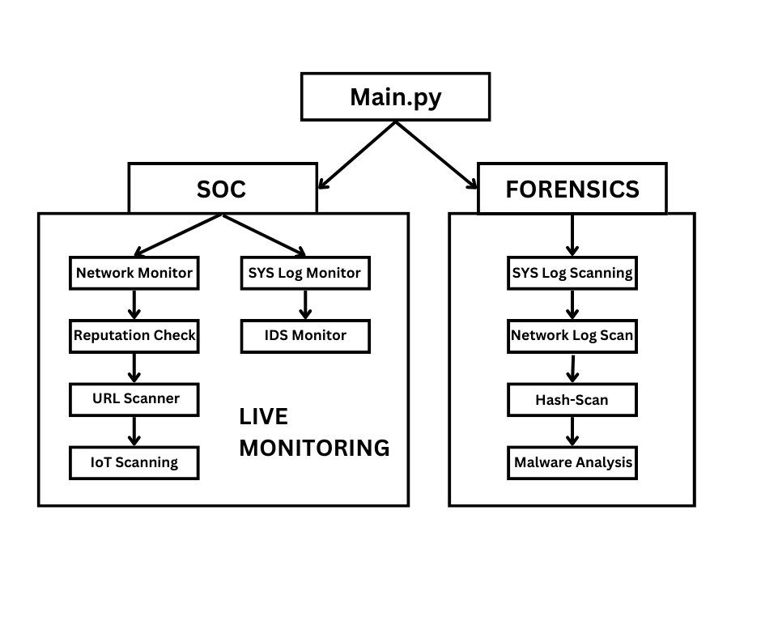

Fig 6.2.1 Flow chart for SOC & Forensic Tool

**6.3 HTTP TEMPERING:**

**6.3.1 INTRODUCTION:**

HTTP tampering, often referred to as HTTP request tampering or HTTP response tampering, is a type of cyber attack in which an attacker intercepts and modifies the HTTP (Hypertext Transfer Protocol) requests or responses exchanged between a client (usually a web browser) and a server. HTTP is the foundation of data communication on the World Wide Web, and tampering with it can lead to various security risks and malicious activities.

**6.3.2 COMMON WAYS:**

1. **Request Tampering:** In this scenario, an attacker intercepts the HTTP request sent by a client to a web server. They may modify parameters, headers, or other data within the request to manipulate the server's response.
2. **Response Tampering:** Attackers can also intercept the HTTP response from a web server to a client. They may modify the content of the response, inject malicious scripts or malware, or tamper with cookies, leading to various attacks like Cross-Site Scripting (XSS), data injection, or session hijacking.
3. **Man-in-the-Middle (MitM) Attacks:** HTTP tampering is often facilitated by MitM attacks, where an attacker intercepts and monitors the communication between a client and a server. By doing this, they can tamper with both requests and responses as they pass through, enabling various attacks.
4. **Cookie Tampering:** Cookies are commonly used for session management and user authentication in web applications. Attackers can tamper with cookies by intercepting and modifying them to gain unauthorized access to user accounts or manipulate application behavior.

**6.3.3 MEASURES TO PROTECT:**

1. **HTTPS (HTTP Secure):** Use HTTPS to encrypt the communication between clients and servers, making it more difficult for attackers to intercept and tamper with data.
2. **Input Validation:** Implement input validation and sanitization on the server side to prevent malicious input from affecting the application.
3. **Content Security Policies (CSP):** Use CSP headers to control which scripts and resources can be executed or loaded on a web page, reducing the risk of XSS attacks.
4. **Secure Cookies:** Set secure and HttpOnly flags on cookies to prevent tampering. Secure cookies can only be transmitted over HTTPS, and HttpOnly cookies are inaccessible to JavaScript, reducing the risk of XSS attacks.
5. **Transport Layer Security (TLS):** Employ strong TLS configurations to ensure secure encryption during data transmission.
6. **Web Application Firewalls (WAFs):** WAFs can help filter and block malicious traffic and requests, including those related to HTTP tampering.
7. **Monitoring and Intrusion Detection:** Implement real-time monitoring and intrusion detection systems to detect and respond to suspicious activities.

**6.4 CROSS SITE SCRIPTING:**

**6.4.1 INTRODUCTION:**

Cross-Site Scripting (XSS) is a type of security vulnerability or attack that occurs when an attacker injects malicious scripts (usually JavaScript) into web pages viewed by other users. The main objective of an XSS attack is to execute the injected script within the context of a victim's web browser, allowing the attacker to steal information, manipulate the web page, or perform other malicious actions on behalf of the victim.

**6.4.2 TYPES:**

**1. Stored XSS (Persistent XSS):** In this type of attack, the malicious script is permanently stored on the target web server. When a user visits a page containing the injected script, it is retrieved from the server and executed in the context of the user's browser. This type of XSS attack can have long-lasting effects and can affect multiple users who access the compromised page.

**2. Reflected XSS (Non-Persistent XSS): Reflected** XSS occurs when the injected script is reflected off a web server or another source and is immediately executed in the user's browser. It is typically delivered through a URL or input fields. The attacker often entices victims to click on a specially crafted link or visit a particular web page. Unlike stored XSS, the malicious script is not permanently stored on the server and only affects users who access the manipulated URL.

**3. DOM-based XSS:** DOM (Document Object Model) XSS is a variant of XSS in which the attack is performed entirely on the client side, and the malicious script manipulates the Document Object Model of a web page. The attacker typically exploits vulnerable client-side code or JavaScript frameworks to execute the attack.

**6.4.3 MEASURES TO PREVENT:**

**1. Input Validation and Sanitization:** Validate and sanitize user inputs on the server side to prevent any untrusted data from being included in web pages. Use libraries and frameworks that provide protection against XSS, such as Content Security Policy (CSP).

**2. Output Encoding:** Encode or escape data before rendering it in HTML, JavaScript, or other contexts. This makes it difficult for attackers to inject malicious code.

**3. Content Security Policy (CSP):** Implement CSP headers to specify which sources of content are allowed to be loaded and executed on a web page. CSP can block or report attempts at executing malicious scripts.

**4. Use HTTPS:** Ensure that your web application uses HTTPS to encrypt data in transit, reducing the risk of man-in-the-middle attacks that might lead to XSS.

**5. Web Application Firewalls (WAFs):** Employ a WAF to filter and block malicious requests, including those that may be related to XSS.

XSS attacks can have serious consequences, including data theft, session hijacking, defacement of web pages, and more. It's crucial for web developers and administrators to be aware of XSS vulnerabilities and take measures to prevent them in their applications.

**6.5 SQL INJECTION:**

**6.5.1 INTRODUCTION**

SQL Injection (SQLi) is a type of security vulnerability and cyber attack that occurs when an attacker is able to manipulate a web application's SQL query through user inputs. This vulnerability arises when user inputs, which are not properly validated or sanitized, are directly incorporated into SQL queries used by the application to interact with a database. By injecting malicious SQL code, attackers can gain unauthorized access to the database, view, modify, or delete data, and potentially execute administrative tasks on the database server.

**6.5.2 SAMPLE QUERIES:**

```sql

SELECT * FROM products WHERE product_name = '<user_input>';

```

If the application doesn't properly validate or sanitize the user input and an attacker enters the following input:

```plaintext

' OR '1'='1

```

The SQL query would become:

```sql

SELECT * FROM products WHERE product_name = '' OR '1'='1';

```

In this case, the attacker's input effectively turns the query into a true statement ('1'='1'), which results in the application retrieving all the records from the "products" table, potentially exposing sensitive data.

**6.5.3 MEASURES TO PREVENT:**

**1. Parameterized Statements (Prepared Statements):** Instead of embedding user inputs directly into SQL queries, use parameterized statements provided by your programming language or framework. These statements automatically handle the proper escaping and quoting of user inputs.

**2. Input Validation and Sanitization:** Ensure that user inputs are validated and sanitized on the server side to eliminate or neutralize any potentially malicious input.

**3. Least Privilege Principle:** Ensure that your application's database connections have the least privilege necessary to perform their tasks. Avoid using superuser accounts for application access.

**4. Web Application Firewall (WAF):** Implement a WAF to filter and block malicious requests, including those attempting SQL injection.

**5. Database Security:** Keep your database software and servers up to date, apply security patches, and use security configurations to minimize potential attack vectors.

**6. Error Handling:** Avoid displaying detailed error messages to users, as these messages may provide valuable information to attackers. Log error messages internally for debugging purposes.

**7. Regular Security Audits and Penetration Testing:** Periodically audit your application's code and perform penetration testing to identify and fix vulnerabilities, including potential SQL injection issues.

SQL injection can have severe consequences, including data breaches, data manipulation, and potentially complete compromise of a web application and its associated database.

**6.6 USER INTERFACE:**

**6.6.1 INTRODUCTION:**

**Tool: Tkinter**

Tkinter is a standard Python library (included with most Python installations) for creating graphical user interfaces (GUIs). It provides a set of tools and widgets for building windows, dialog boxes, buttons, menus, and other GUI elements for your Python applications. Tkinter is based on the Tk GUI toolkit, which is widely used for building GUI applications.

**6.6.2 MAIN CODE:**

import tkinter as tk

from tkinter import ttk

from tkinter import filedialog

from tkinter import scrolledtext

from ttkthemes import ThemedStyle

import subprocess

import sys

import json

from bs4 import BeautifulSoup

import requests

class Vulnerability:

def __init__(self, name, severity, description):

self.name = name

self.severity = severity

self.description = description

class VulnerabilityScanner:

def __init__(self, root):

self.root = root

self.root.title('Web Vulnerability Scanner')

self.root.geometry('800x550')

self.tabs = ttk.Notebook(root)

self.tab1 = ttk.Frame(self.tabs)

self.tab2 = ttk.Frame(self.tabs)

self.tab3 = ttk.Frame(self.tabs)

self.tab4 = ttk.Frame(self.tabs)

self.tab6 = ttk.Frame(self.tabs)

self.create_scan_tab()

self.create_upload_tab()

self.create_report_tab()

self.create_about_tab()

self.create_url_validation_tab()

self.tabs.add(self.tab1, text="Scan")

self.tabs.add(self.tab2, text="Upload Files")

self.tabs.add(self.tab3, text="Report")

self.tabs.add(self.tab6, text="URL Validation")

self.tabs.add(self.tab4, text="About")

self.tabs.pack(fill="both", expand=True)

def create_scan_tab(self):

self.url_label = ttk.Label(self.tab1, text='Enter URL:')

self.url_edit = ttk.Entry(self.tab1)

self.scan_button = ttk.Button(self.tab1, text='Scan', command=self.scan)

self.log_box = scrolledtext.ScrolledText(self.tab1, wrap=tk.WORD)

self.export_button = ttk.Button(self.tab1, text='Export Log')

self.attacks_label = ttk.Label(self.tab1, text='Select Attacks:')

# Create a frame to contain the checkboxes on the left

checkbox_frame = ttk.Frame(self.tab1)

checkbox_frame.grid(row=2, column=0, padx=5, pady=5, sticky='w')

self.attack_checkboxes = {

'SQL Injection': tk.IntVar(),

'XSS': tk.IntVar(),

'WHOIS': tk.IntVar(),

'CSRF': tk.IntVar(),

'HTTP Tampering': tk.IntVar()

}

# Arrange checkboxes on the left side

for i, (attack, var) in enumerate(self.attack_checkboxes.items()):

ttk.Checkbutton(checkbox_frame, text=attack, variable=var).grid(row=i, column=0, padx=5, pady=5, sticky='w')

self.url_label.grid(row=0, column=1, padx=5, pady=5, sticky='w')

self.url_edit.grid(row=0, column=2, padx=5, pady=5)

self.scan_button.grid(row=0, column=3, padx=5, pady=5)

self.attacks_label.grid(row=1, column=1, padx=5, pady=5, sticky='w')

self.log_box.grid(row=2, column=1, columnspan=3, padx=5, pady=5)

self.export_button.grid(row=3, column=1, padx=5, pady=5, sticky='w')

def create_upload_tab(self):

self.file_label = ttk.Label(self.tab2, text='Select File for Analysis:')

self.file_edit = ttk.Entry(self.tab2)

self.browse_button = ttk.Button(self.tab2, text='Browse', command=self.browse_file)

self.upload_button = ttk.Button(self.tab2, text='Upload and Analyze', command=self.upload_and_analyze)

self.upload_status = tk.StringVar()

upload_status_label = ttk.Label(self.tab2, textvariable=self.upload_status)

self.file_label.grid(row=0, column=0, padx=5, pady=5, sticky='w')

self.file_edit.grid(row=0, column=1, padx=5, pady=5)

self.browse_button.grid(row=0, column=2, padx=5, pady=5)

self.upload_button.grid(row=1, column=0, padx=5, pady=5, sticky='w')

upload_status_label.grid(row=1, column=1, columnspan=2, padx=5, pady=5, sticky='w')

def create_report_tab(self):

self.report_button = ttk.Button(self.tab3, text='Generate Report', command=self.generate_report)

self.report_log = scrolledtext.ScrolledText(self.tab3, wrap=tk.WORD)

self.export_report_button = ttk.Button(self.tab3, text='Export Report', command=self.export_report)

self.report_button.grid(row=0, column=0, padx=5, pady=5, sticky='w')

self.report_log.grid(row=1, column=0, columnspan=3, padx=5, pady=5)

self.export_report_button.grid(row=2, column=1, padx=5, pady=5, sticky='w')

def create_about_tab(self):

about_text = """

Developed by Dekode Security Team

V.SHANMUGAM

R.KAPILSURYA

R.SARANKUMAR

4th Year Cyber Security

Paavai Engineering College

"""

about_label = ttk.Label(self.tab4, text=about_text, font=('Helvetica', 14))

about_label.grid(padx=20, pady=20)

def create_live_ip_monitor_tab(self):

self.ip_label = ttk.Label(self.tab5, text='Enter IP Address:')

self.ip_edit = ttk.Entry(self.tab5)

self.search_button = ttk.Button(self.tab5, text='Search IP Details', command=self.search_ip_details)

self.ip_details_log = scrolledtext.ScrolledText(self.tab5, wrap=tk.WORD)

self.ip_label.grid(row=0, column=0, padx=5, pady=5, sticky='w')

self.ip_edit.grid(row=0, column=1, padx=5, pady=5)

self.search_button.grid(row=1, column=0, padx=5, pady=5, sticky='w')

self.ip_details_log.grid(row=2, column=0, columnspan=3, padx=5, pady=5)

def scan(self):

url = self.url_edit.get()

selected_attacks = [attack for attack, var in self.attack_checkboxes.items() if var.get() == 1]

vulnerabilities = self.check_vulnerabilities(url, selected_attacks)

self.log_vulnerabilities(vulnerabilities)

if 'SQL Injection' in selected_attacks:

self.run_sqlmap(url)

if 'XSS' in selected_attacks:

self.run_xxs_strike(url)

if 'WHOIS' in selected_attacks:

self.run_see_surf(url)

if 'CSRF' in selected_attacks:

self.run_bolt(url)

if 'HTTP Tampering' in selected_attacks:

self.run_smuggler_master(url)

def run_xxs_strike(self, url):

path = r'C:\Users\shanm\OneDrive\Desktop\Project WEB PENETRATER\XSStrike-master\xsstrike.py'

xxs_strike_command = [sys.executable, path, '-u', url]

try:

xxs_strike_output = subprocess.check_output(xxs_strike_command, universal_newlines=True)

self.log_box.insert(tk.END, f'XXStrike Output:\n{xxs_strike_output}\n')

except subprocess.CalledProcessError as e:

self.log_box.insert(tk.END, f'Error running XXStrike: {e}\n')

def run_sqlmap(self, url):

path = r'C:\Users\shanm\OneDrive\Desktop\Project WEB PENETRATER\sqlmap-master\sqlmap.py'

sqlmap_command = [sys.executable, path, '-u', url]

try:

sqlmap_output = subprocess.check_output(sqlmap_command, universal_newlines=True)

self.log_box.insert(tk.END, f'SQLMap Output:\n{sqlmap_output}\n')

except subprocess.CalledProcessError as e:

self.log_box.insert(tk.END, f'Error running SQLMap: {e}\n')

def run_see_surf(self, url):

path=r'C:\Users\shanm\OneDrive\Desktop\Project WEB PENETRATER\whois\whoislookup.py'

see_surf_command = [sys.executable, path, '-u', url]

try:

see_surf_output = subprocess.check_output(see_surf_command, universal_newlines=True)

self.log_box.insert(tk.END, f'See-Surf Output:\n{see_surf_output}\n')

except subprocess.CalledProcessError as e:

self.log_box.insert(tk.END, f'Error running See-Surf: {e}\n')

def run_bolt(self, url):

path1= r'C:\Users\shanm\OneDrive\Desktop\Project WEB PENETRATER\TechViper-main\TechViper.py'

bolt_command = ['python', path1, '-u' ,url]

try:

bolt_output = subprocess.check_output(bolt_command, universal_newlines=True, stderr=subprocess.STDOUT)

self.log_box.insert(tk.END, f'bolt Master Output:\n{bolt_output}\n')

except subprocess.CalledProcessError as e:

self.log_box.insert(tk.END, f'Error running bolt Master: {e}\n')

def run_smuggler_master(self, url):

path= r'C:\Users\shanm\OneDrive\Desktop\Project WEB PENETRATER\smuggler-master\smuggler-master\smuggler.py'

smuggler_master_command = [sys.executable, path, '-u' ,url]

try:

smuggler_master_output = subprocess.check_output(smuggler_master_command, universal_newlines=True)

self.log_box.insert(tk.END, f'Smuggler Master Output:\n{smuggler_master_output}\n')

except subprocess.CalledProcessError as e:

self.log_box.insert(tk.END, f'Error running Smuggler Master: {e}\n')

def check_vulnerabilities(self, url, selected_attacks):

# Existing vulnerability check logic

vulnerabilities = [

#Vulnerability('SQL Injection', 'High', 'This is an SQL injection vulnerability.'),

#Vulnerability('XSS', 'Medium', 'This is a Cross-Site Scripting vulnerability.'),

]

return vulnerabilities

def log_vulnerabilities(self, vulnerabilities):

self.log_box.delete(1.0, tk.END)

for vuln in vulnerabilities:

self.log_box.insert(tk.END,

f'Vulnerability: {vuln.name}\nSeverity: {vuln.severity}\nDescription: {vuln.description}\n\n')

def export_log(self):

log_text = self.log_box.get(1.0, tk.END)

with open('vulnerability_log.txt', 'w') as log_file:

log_file.write(log_text)

def browse_file(self):

file_path = filedialog.askopenfilename(filetypes=[('All Files', '*.*')])

self.file_edit.delete(0, tk.END)

self.file_edit.insert(0, file_path)

def create_upload_tab(self):

self.file_label = ttk.Label(self.tab2, text='Select File for Analysis:')

self.file_edit = ttk.Entry(self.tab2)

self.browse_button = ttk.Button(self.tab2, text='Browse', command=self.browse_file)

self.upload_button = ttk.Button(self.tab2, text='Upload and Analyze', command=self.upload_and_analyze)

self.upload_status = tk.StringVar()

upload_status_label = ttk.Label(self.tab2, textvariable=self.upload_status)

# ScrolledText widget to display the log for upload and analyze action

self.upload_log = scrolledtext.ScrolledText(self.tab2, wrap=tk.WORD)

self.file_label.grid(row=0, column=0, padx=5, pady=5, sticky='w')

self.file_edit.grid(row=0, column=1, padx=5, pady=5)

self.browse_button.grid(row=0, column=2, padx=5, pady=5)

self.upload_button.grid(row=1, column=0, padx=5, pady=5, sticky='w')

upload_status_label.grid(row=1, column=1, columnspan=2, padx=5, pady=5, sticky='w')

# Grid the upload log widget below the button

self.upload_log.grid(row=2, column=0, columnspan=3, padx=5, pady=5)

def upload_and_analyze(self):

file_path = self.file_edit.get()

if not file_path:

self.upload_status.set("Please select a file to analyze.")

return

try:

api_key = '4d8f690e8cbae5ad547e9a9712a0713b38206dfd1b9d0ecdaaa512d6817e37fa'

# Upload the file to VirusTotal

url = 'https://www.virustotal.com/vtapi/v2/file/scan'

params = {'apikey': api_key}

files = {'file': (file_path, open(file_path, 'rb'))}

response = requests.post(url, files=files, params=params)

if response.status_code == 200:

result = response.json()

resource = result.get('resource')

# Check the analysis report for the uploaded file

report_url = f'https://www.virustotal.com/gui/file/{resource}/detection'

# Fetch the analysis report

report_api_url = f'https://www.virustotal.com/vtapi/v2/file/report'

report_params = {'apikey': api_key, 'resource': resource}

report_response = requests.get(report_api_url, params=report_params)

if report_response.status_code == 200:

report_data = report_response.json()

analysis_output = json.dumps(report_data, indent=4)

self.upload_log.delete(1.0, tk.END)

self.upload_log.insert(tk.END, analysis_output)

self.upload_status.set(f"File uploaded to Successfully")

else:

self.upload_status.set("Error fetching the report from VirusTotal.")

else:

self.upload_status.set("Error uploading the file to VirusTotal.")

self.upload_log.delete(1.0, tk.END)

self.upload_log.insert(tk.END, "Error uploading the file to VirusTotal.")

except Exception as e:

self.upload_status.set(f"Check your connection / System not connected to internet")

self.upload_log.delete(1.0, tk.END)

self.upload_log.insert(tk.END, f"Error: {str(e)}")

def generate_report(self):

log_text = self.log_box.get(1.0, tk.END)

self.report_log.delete(1.0, tk.END)

self.report_log.insert(tk.END, log_text)

def export_report(self):

report_text = self.report_log.get(1.0, tk.END)

with open('vulnerability_report.txt', 'w') as report_file:

report_file.write(report_text)

def create_url_validation_tab(self):

self.url_validate_label = ttk.Label(self.tab6, text='Enter URL to Validate:')

self.url_validate_edit = ttk.Entry(self.tab6)

self.validate_button = ttk.Button(self.tab6, text='Validate URL', command=self.validate_url)

self.validation_log = scrolledtext.ScrolledText(self.tab6, wrap=tk.WORD)

self.validation_log.grid(row=1, column=0, columnspan=3, padx=5, pady=5)

self.url_validate_label.grid(row=0, column=1, padx=5, pady=5, sticky='w')

self.url_validate_edit.grid(row=0, column=2, padx=5, pady=5)

self.validate_button.grid(row=0, column=3, padx=5, pady=5)

def validate_url(self):

url = self.url_validate_edit.get()

if not url:

self.validation_log.delete(1.0, tk.END)

self.validation_log.insert(tk.END, 'Please enter a URL to validate.')

return

try:

api_key = '4d8f690e8cbae5ad547e9a9712a0713b38206dfd1b9d0ecdaaa512d6817e37fa'

# Check if the URL is already in the database

url_report_url = 'https://www.virustotal.com/vtapi/v2/url/report'

url_report_params = {'apikey': api_key, 'resource': url}

url_report_response = requests.get(url_report_url, params=url_report_params)

url_report_data = url_report_response.json()

if url_report_data['response_code'] == 1:

self.validation_log.delete(1.0, tk.END)

self.validation_log.insert(tk.END, 'This URL is already in the VirusTotal database. Here is the analysis report:\n')

# Extract and format the report data

report = url_report_data['verbose_msg']

scan_results = url_report_data.get('scans', {})

for engine, result in scan_results.items():

report += f"\nEngine: {engine}, Result: {result['result']}"

self.validation_log.insert(tk.END, report)

else:

# Submit the URL for analysis

url_scan_url = 'https://www.virustotal.com/vtapi/v2/url/scan'

url_scan_params = {'apikey': api_key, 'url': url}

url_scan_response = requests.post(url_scan_url, data=url_scan_params)

url_scan_data = url_scan_response.json()

if url_scan_data['response_code'] == 1:

self.validation_log.delete(1.0, tk.END)

self.validation_log.insert(tk.END, 'The URL has been successfully submitted for analysis. You can check the report later.\n')

else:

self.validation_log.delete(1.0, tk.END)

self.validation_log.insert(tk.END, 'Error submitting the URL for analysis.\n')

except Exception as e:

self.validation_log.delete(1.0, tk.END)

self.validation_log.insert(tk.END, f'Error: {str(e)}\n')

if __name__ == '__main__':

root = tk.Tk()

# Create a themed style for ttk widgets

style = ThemedStyle(root)

style.set_theme("plastik") # You can change the theme here (e.g., "clam", "alt", "plastik", etc.)

app = VulnerabilityScanner(root)

root.mainloop()

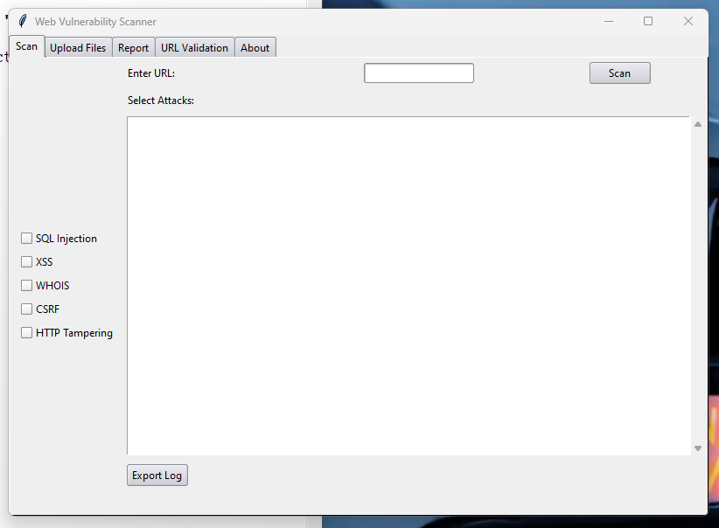**6.6.4 OUTPUT:**

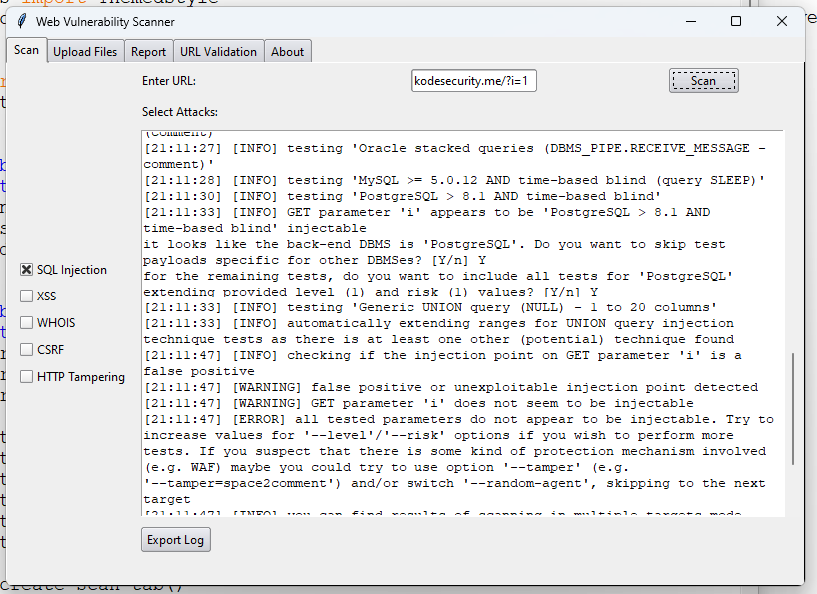Fig 6.6.1 Home page

Fig 6.6.2 SQLi page

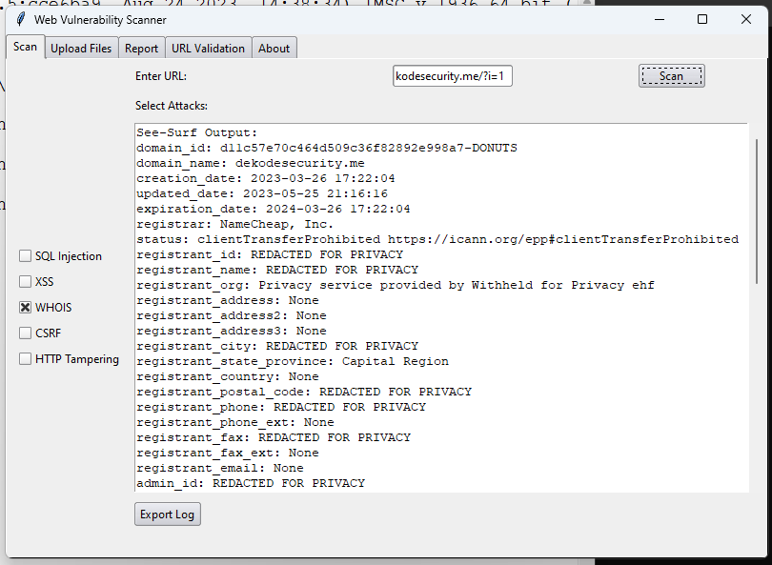Fig 6.6.3 WHO-Is page

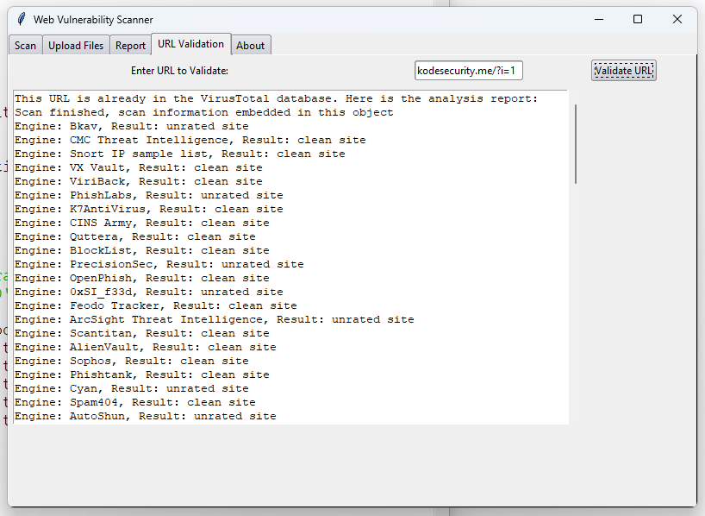

Fig 6.6.4 URL Validation Page

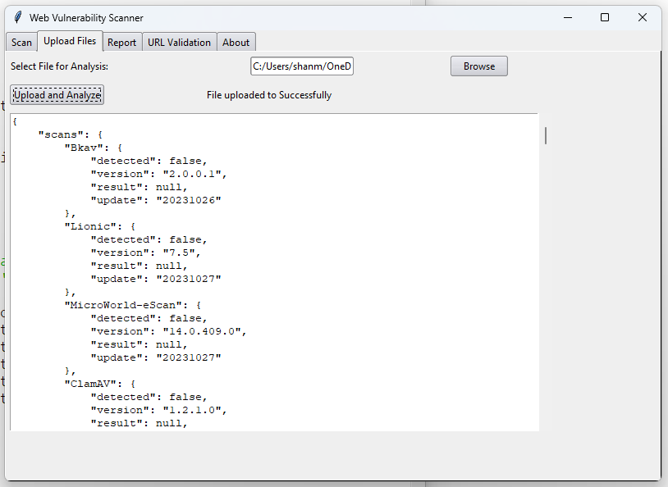

Fig 6.6.5 Upload and Analysis Page

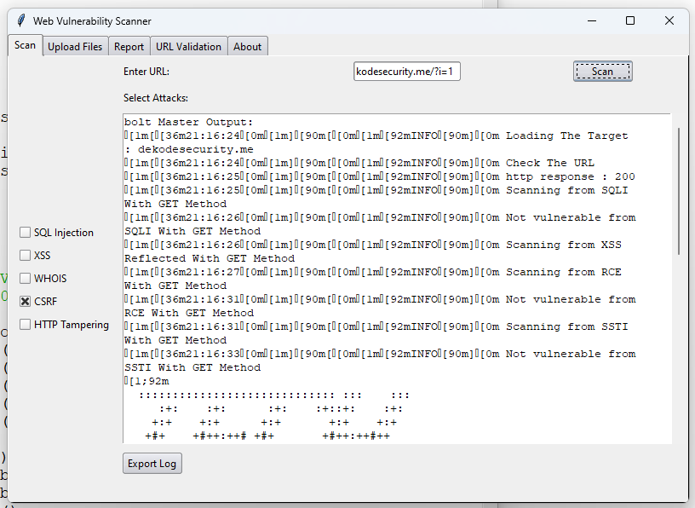

Fig 6.6.6 CSRF Page

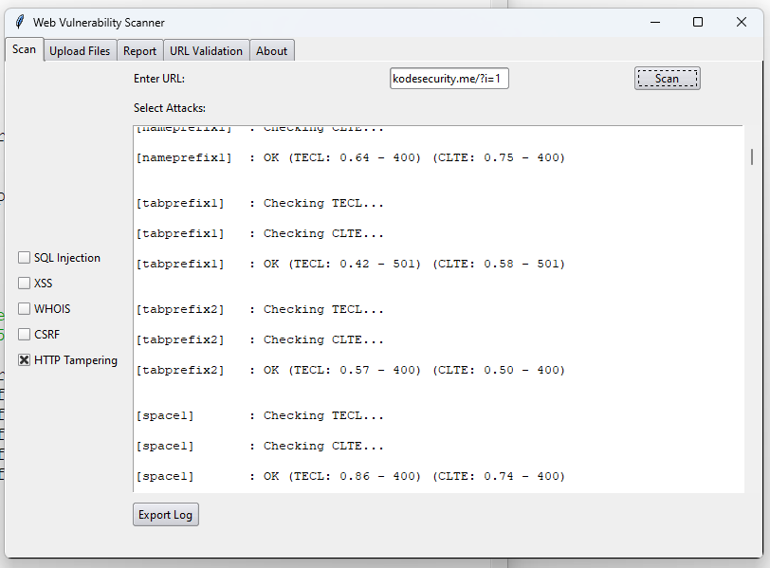Fig 6.6.7 HTTP Tampering Page

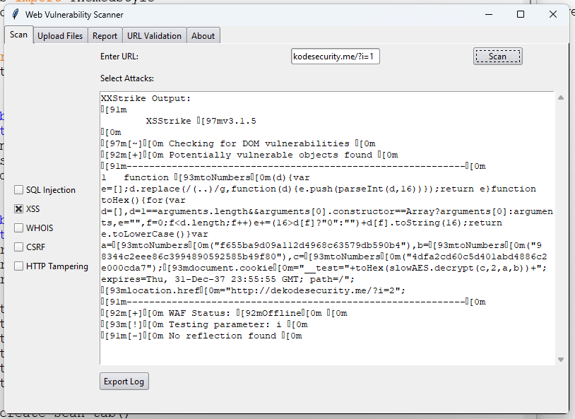

Fig 6.6.8 XSS page

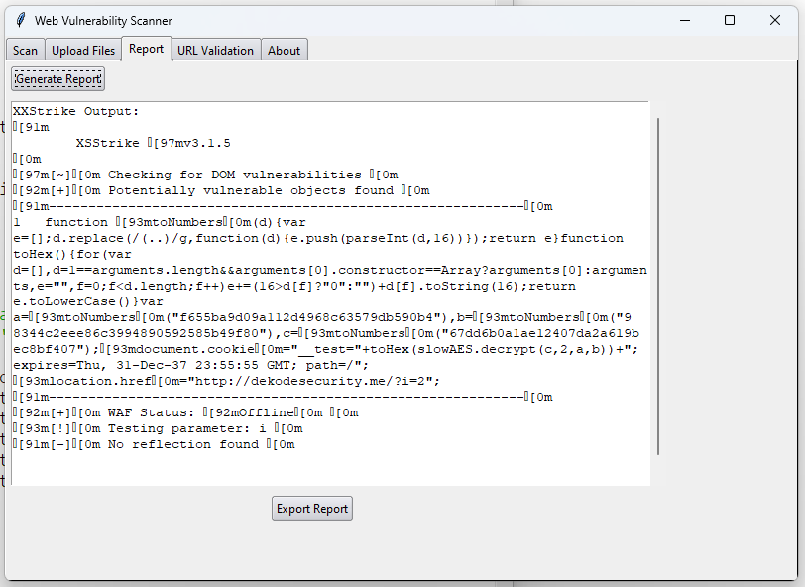

6.6.9 Report Generating Page

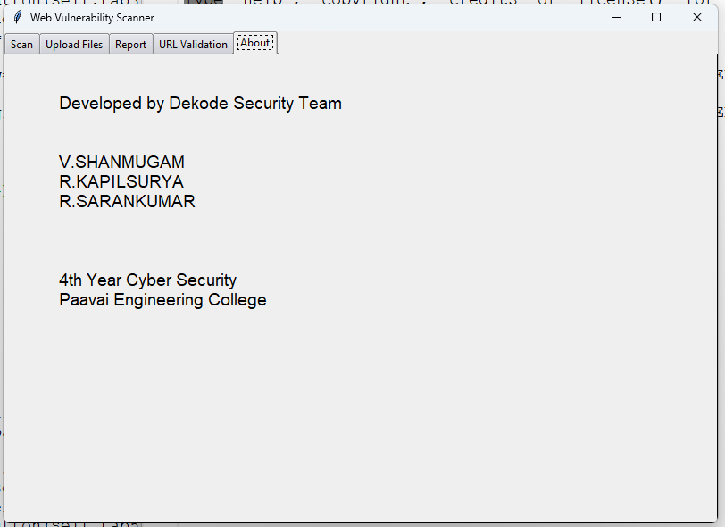

6.6.10 About Page

**CHAPTER-7**

**CONCLUSION**

**7.1 CONCLUSION**

Penetration testing, or pen testing, is a critical process in assessing the security of a web application's user interface (UI). After conducting a thorough assessment, it is essential to draw meaningful conclusions that can inform decision-making, prioritize security improvements, and enhance the overall security posture of the web application.

* Identification of Vulnerabilities
* Severity Assessment
* Common Vulnerabilities
* User Data Protection
* Authentication and Authorization
* Recommendations for Mitigation
* Testing Coverage
* Compliance and Best Practices
* Continuous Improvement
* Post-Testing Actions

In conclusion, the UI web application penetration testing has successfully identified vulnerabilities and provided a roadmap for enhancing security. It is crucial to take the findings seriously and prioritize remediation efforts to protect the application, its users, and the organization from potential security threats. Security is an ongoing journey, and it's important to continually assess and improve the security posture of the web application to stay ahead of emerging threats.

**7.2 ADVANTAGES:**

Automated penetration testing for web application UI offers several advantages:

1. **Scalability:** Automation allows for testing at scale, making it suitable for large and complex web applications with numerous features and functionalities.
2. **Efficiency:** Automated tools can quickly and thoroughly scan the application, identifying vulnerabilities that might be challenging to find through manual testing alone.
3. **Consistency:** Automated tests can be executed consistently and repeatedly, reducing the risk of human error in the testing process.
4. **Timeliness:** Automated testing can be integrated into the development and deployment pipeline, providing real-time feedback to development teams, allowing for swift remediation.
5. **Cost-Effectiveness:** While there may be an initial investment in tools and expertise, automated testing can be more cost-effective in the long run compared to manual testing, especially for applications that undergo frequent updates and changes.

**REFERENCES**

|  |  |
| --- | --- |
|  | Karina Raiküla., April,2023 “Implementation of Automated End-To-End Testing in Web Applications” , Metropolia. |
|  | Lari Harjunen., June,2023 “Optimizing Web Application Security Testing Process in the Financial Sector” , LAUREA. |
|  | Shaik Heena, Bingi Naga Lalitha, Devarasetty Sai Umesh , April,2023 , “Machine learning for web vulnerability detection: the case of cross-site request forgery” , Industrial Engineering Journal. |
|  | Aman Kumar Singh, Gulshan Kumar, Prof. Dr. Prabhat Kumar Vishwakarma , May,2023 , “Automation in manual penetration testing usingbash shell script” , International Research Journal of Modernization in Engineering Technology and Science. |
|  | Aditya Kurniawan1, Mohamad Yusof Darus, Muhammad Azizi Mohd Ariffin,Yohan Muliono1 and Chrisando Ryan Pardomuan , 2022 , “Automation of Quantifying Security Risk Level on Injection Attacks Based on Common Vulnerability Scoring System Metric” , Science and Technology. |
|  | Baillie, C., Standen, M., Schwartz, J., Docking, M., Bowman, D., & Kim, J. (2020) “Cyborg: An autonomous cyber operations research gym”, arXiv preprint arXiv:2002.10667, 2020. |
|  | Brown, A., & Wilson, D. (2018) “Integrating Vulnerability Analysis and Penetration Testing in Cybersecurity Assessments “ |
|  | Chandak, Y., Theocharous, G., Kostas, J., Jordan, S. M., & Thomas, P. S. (2019)“Learning action representations for reinforcement learning” , CoRR, abs/1902.00183, 2019. |
|  | Doe, J., & Smith, S. (2019) “Automating Penetration Testing: A Survey “ , Published on 2019. |
|  | Fabio Massimo Zennaro and Laszlo Erdodi. (2022) , “ Modeling penetration testing with reinforcement learning using capture-the-flag challenges and tabular q-learning. “ , arXiv preprint arXiv:2005.12632 |
|  | Ghanem, M. C., & Chen, T. M. (2020) “ Reinforcement learning for efficient network penetration testing “ ,Published in 2020. |
|  | Hu, Z., Beuran, R., & Tan, Y. (2020) “Automated penetration testing using deep reinforcement learning “ , In 2020 IEEE European Symposium on Security and Privacy Workshops (EuroS&PW), pages 2–10. IEEE, 2020. |
|  | Lee, M., & Clark, E. (2020) “ A Machine Learning Approach for Automated Vulnerability Analysis and Penetration Testing “ , Published on 2020. |
|  | Moore, C., & Anderson, S. (2021) “ Towards Continuous Automated Penetration Testing in Cloud Environments “ , Published on 2021. |
|  | Roberts, A., & White, J. (2020) “ Vulnerability Analysis and Automated Penetration Testing in Industrial Control Systems “ , Published on 2020. |
|  | Schwartz, J., & Kurniawati, H. (2019) “ Autonomous penetration testing using reinforcement learning” , Published in 2019. |
|  | Zennaro, F. M., & Erdodi, L. (2022) “ Modeling penetration testing with reinforcement learning using capture-the-flag challenges and tabular q-learning “ , arXiv preprint arXiv:2005.12632, 2022. |
|  | Christopher Farquhar, Laura Gustafson, Zeming Lin, Shimon Whiteson, Nicolas Usunier, and Gabriel Synnaeve. (2019) “ Growing action spaces. “ , CoRR, abs/1906.12266, 2019. |
|  | Mohamed C. Ghanem and Thomas M. Chen. (2020) “ Reinforcement learning for efficient network penetration testing. “ , Published in 2020. |
|  | Zhenguo Hu, Razvan Beuran, and Yasuo Tan. (2020) ‘ Automated penetration testing using deep reinforcement learning. “ , In 2020 IEEE European Symposium on Security and Privacy Workshops (EuroS&PW), pages 2–10. IEEE, 2020. |